GOVERNANCE AND OPERATIONALIZATION

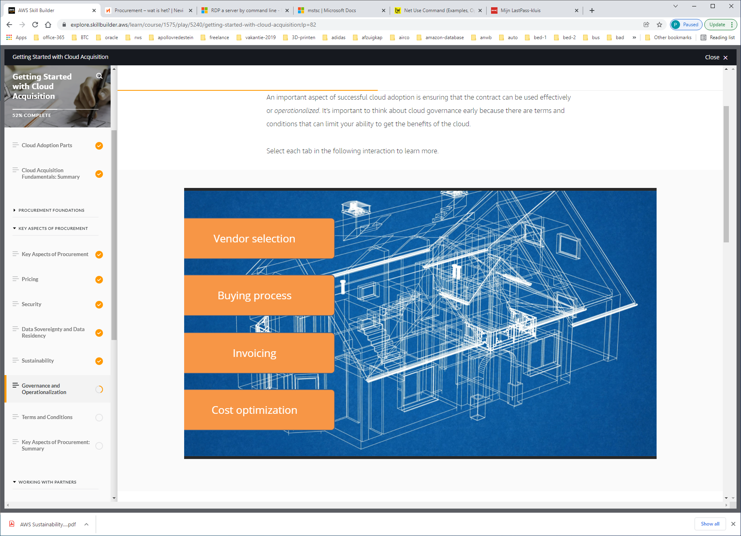

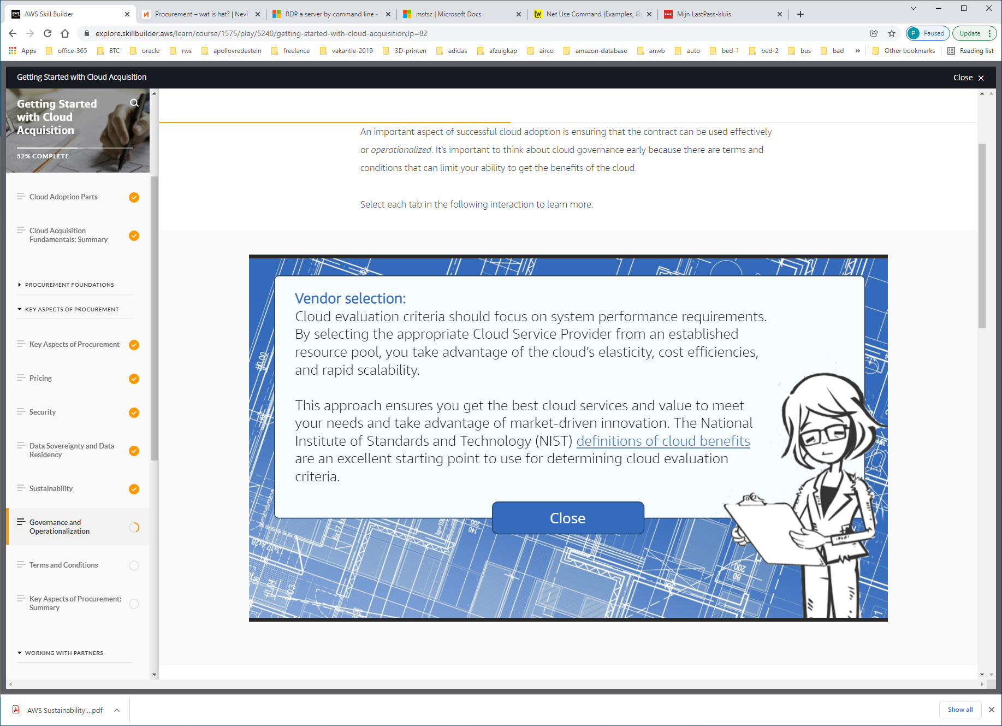

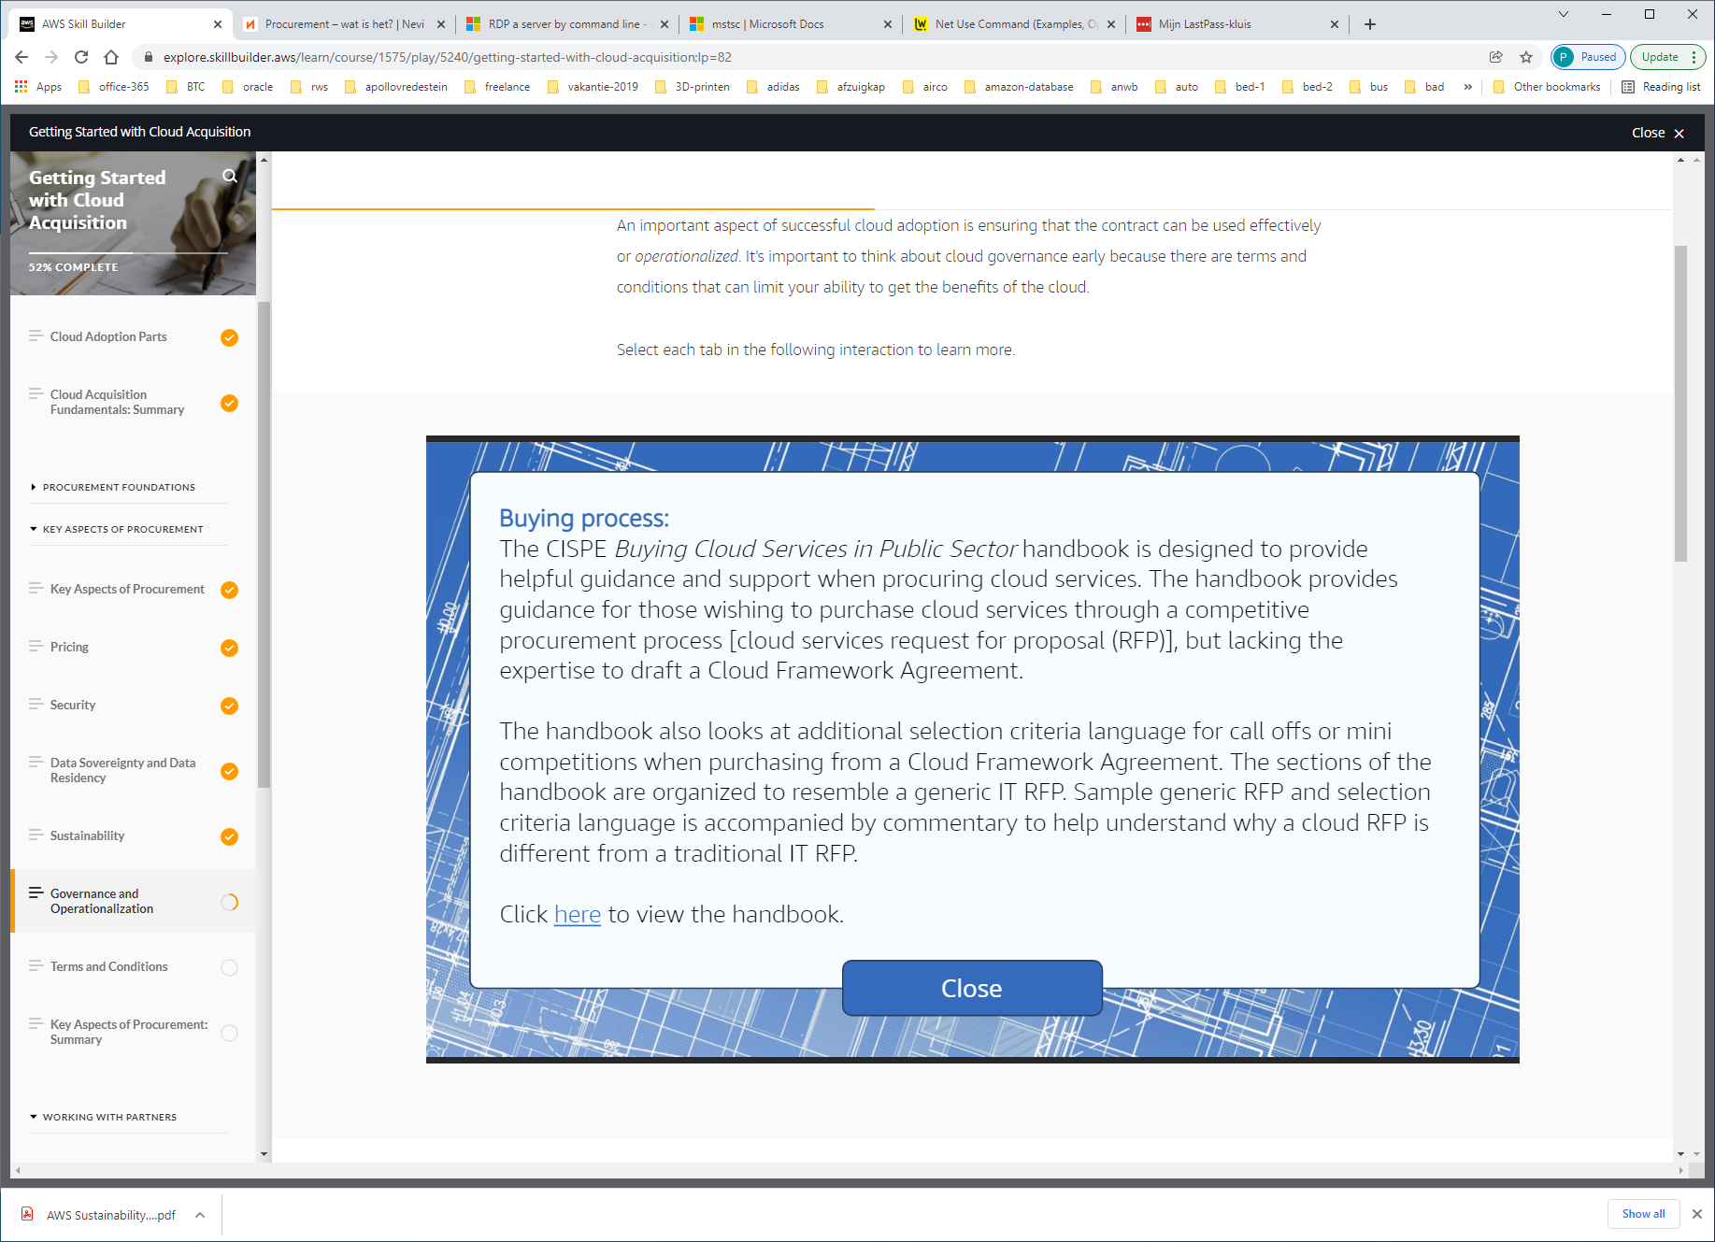

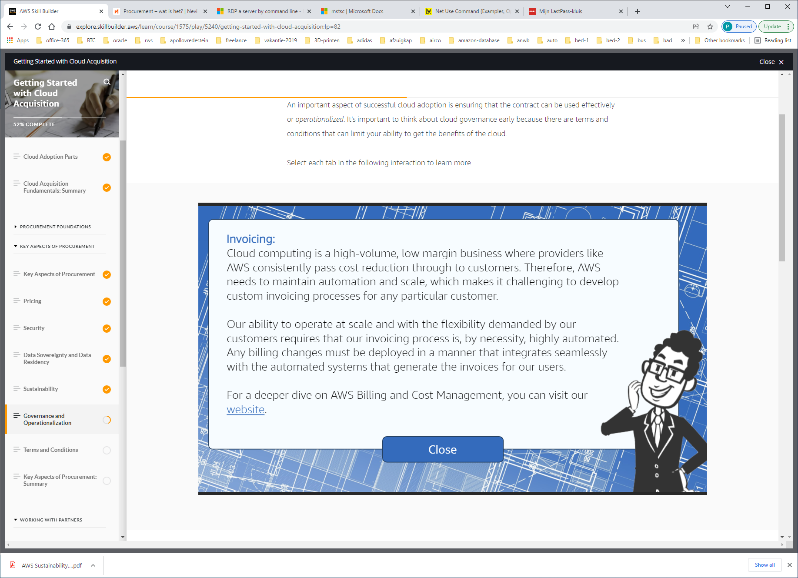

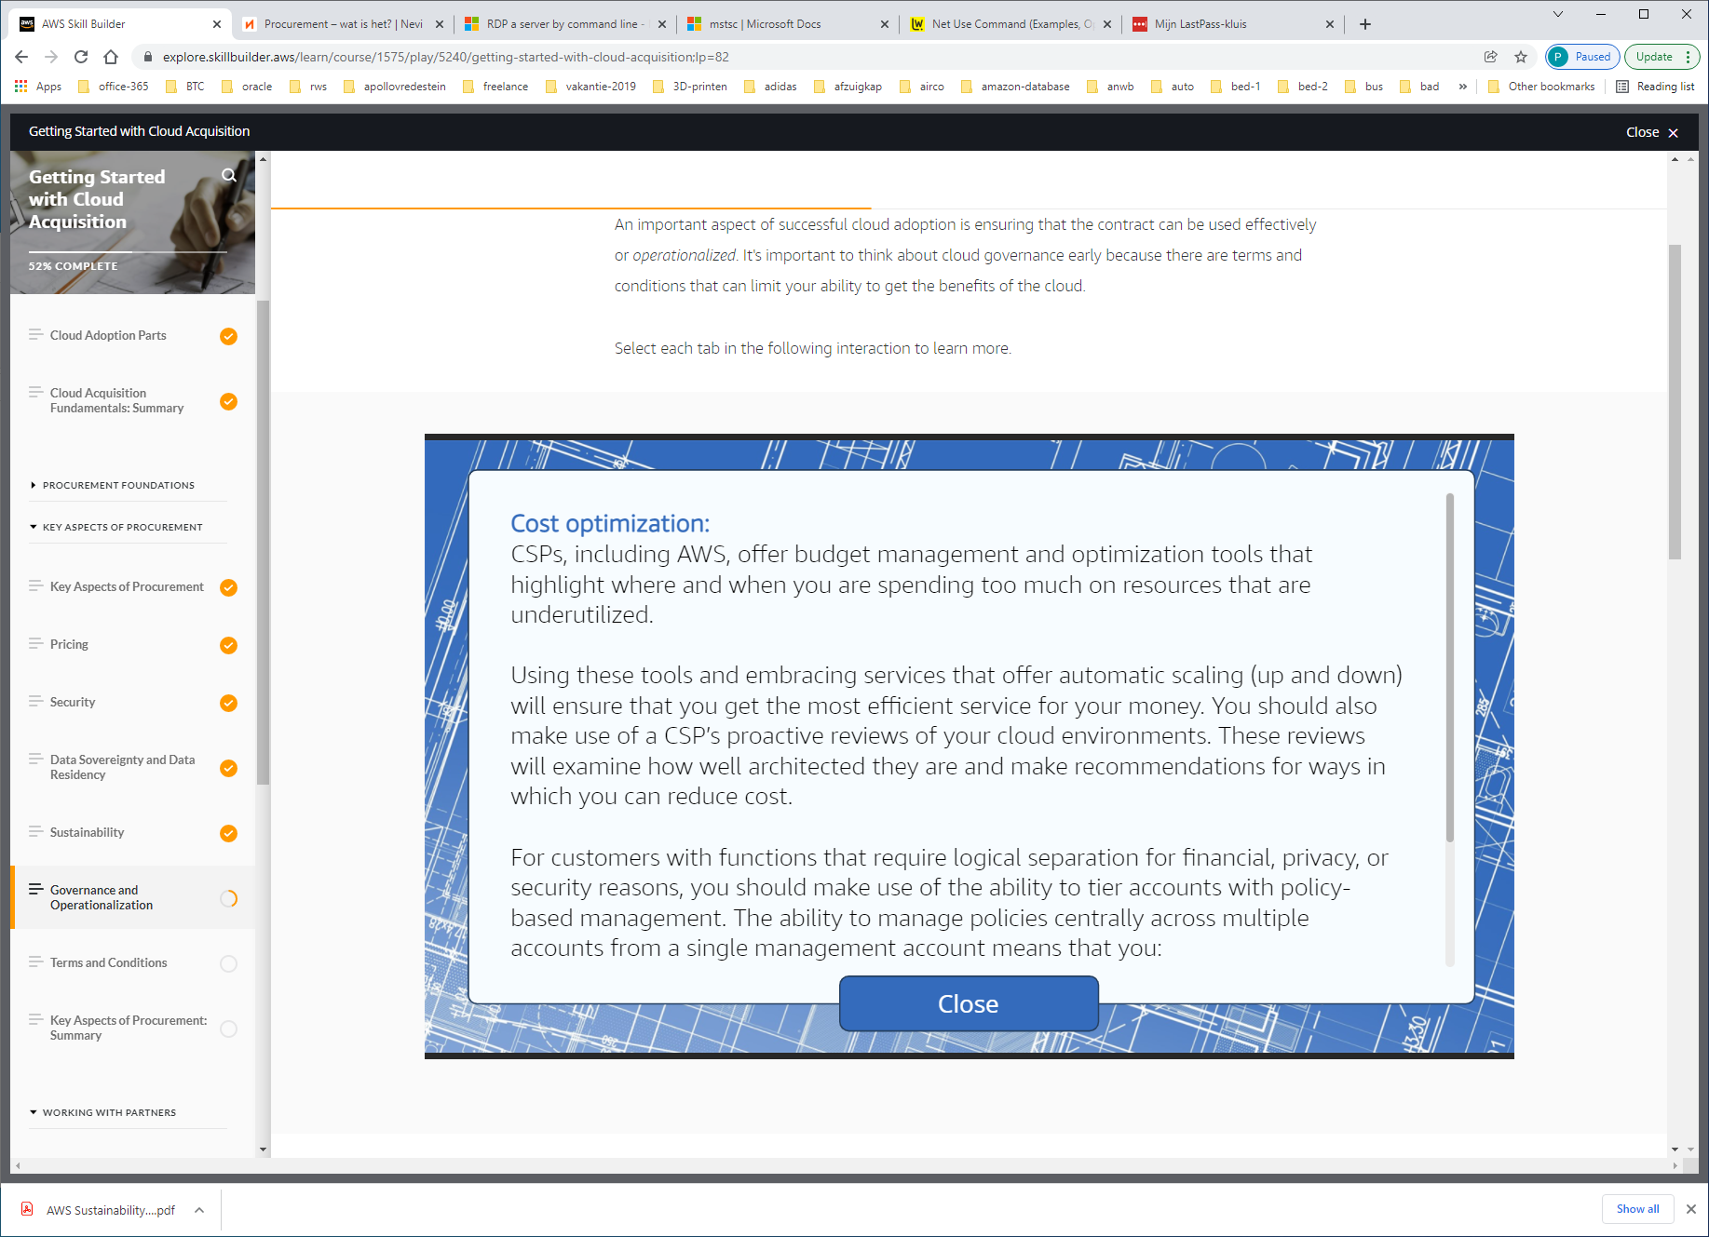

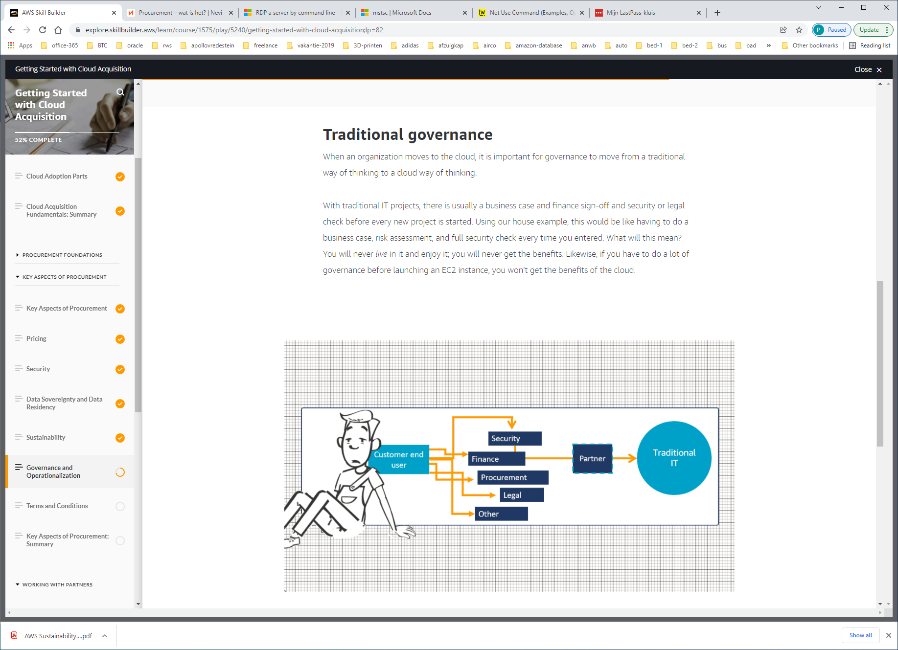

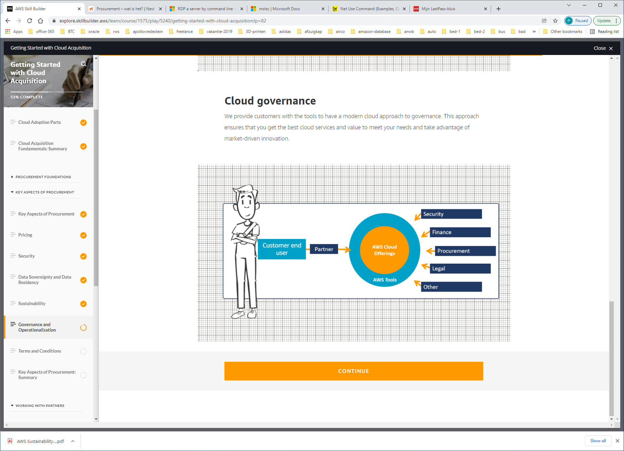

TERMS AND CONDITIONS

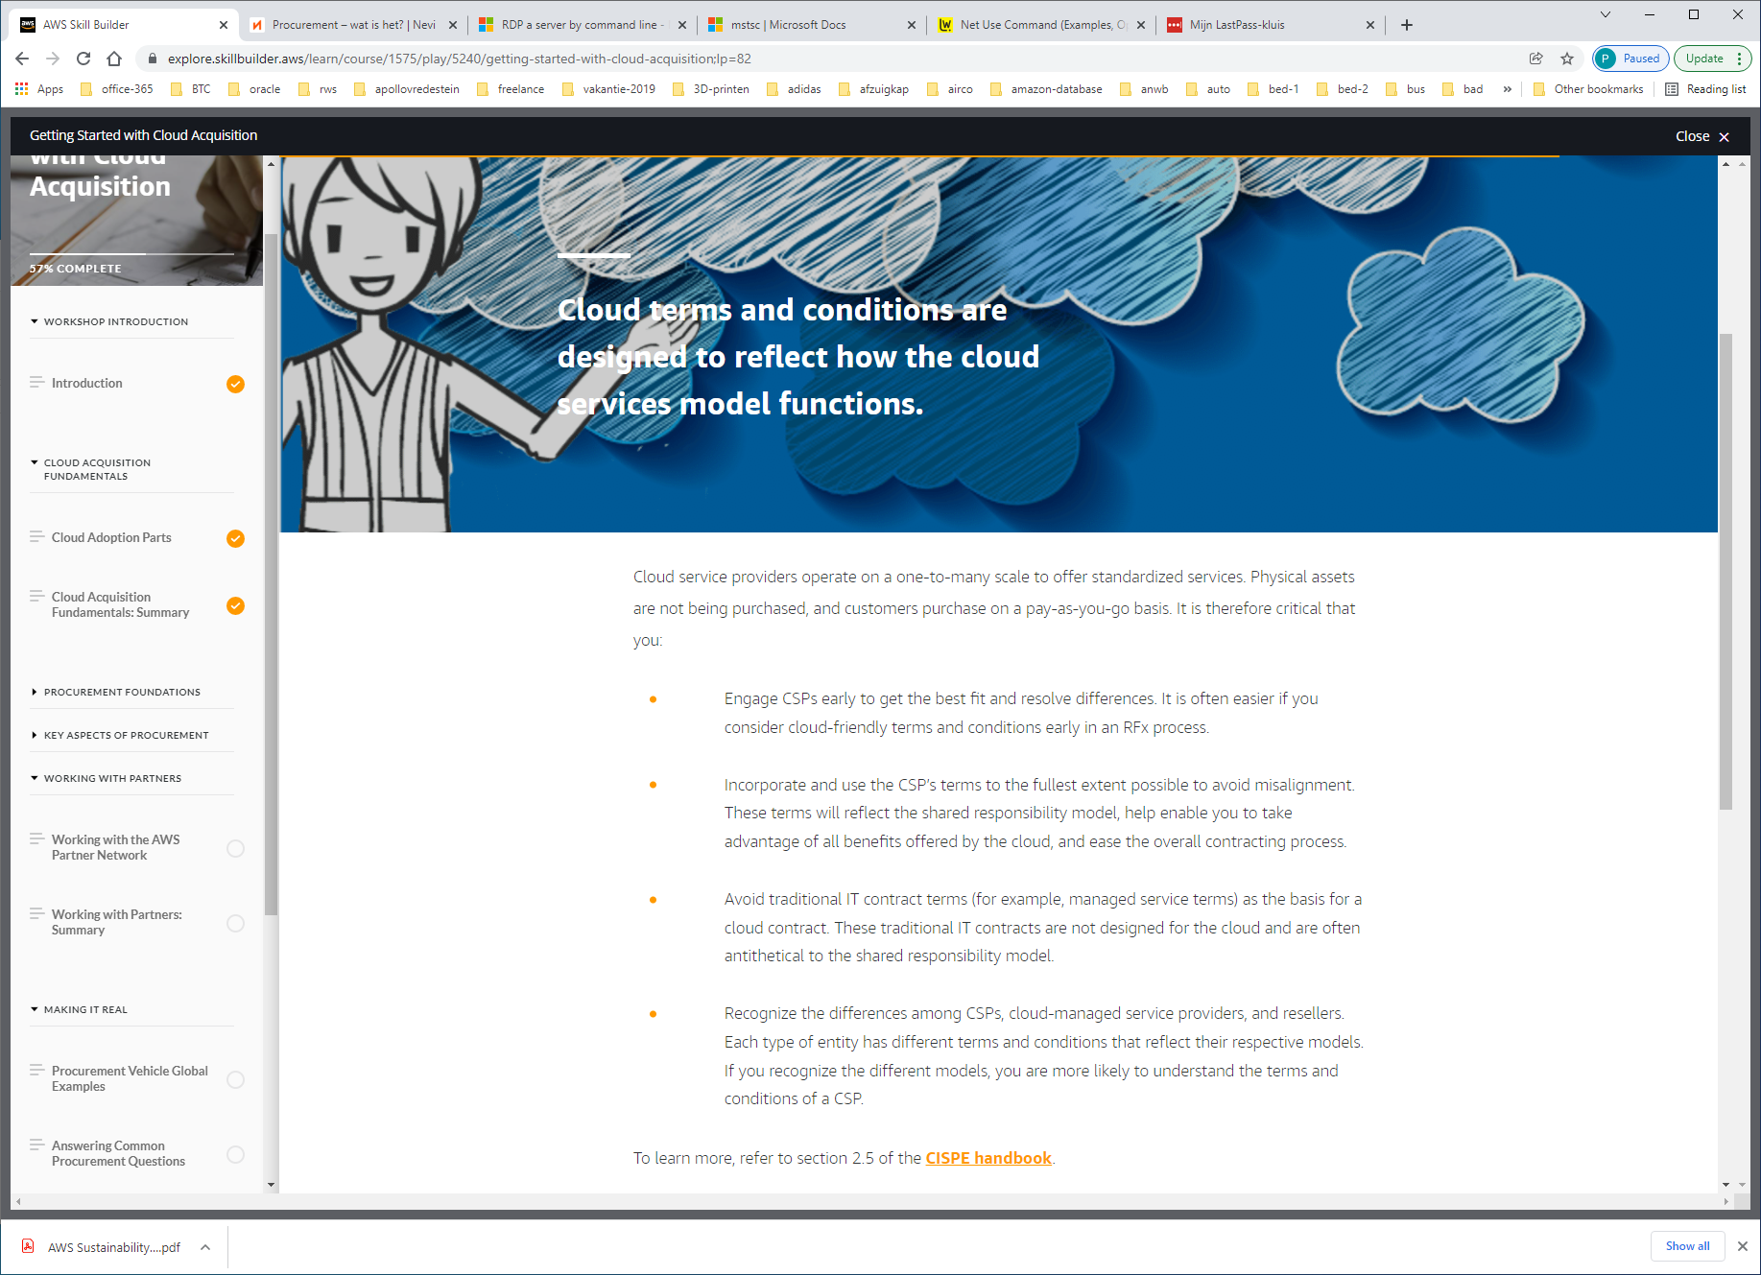

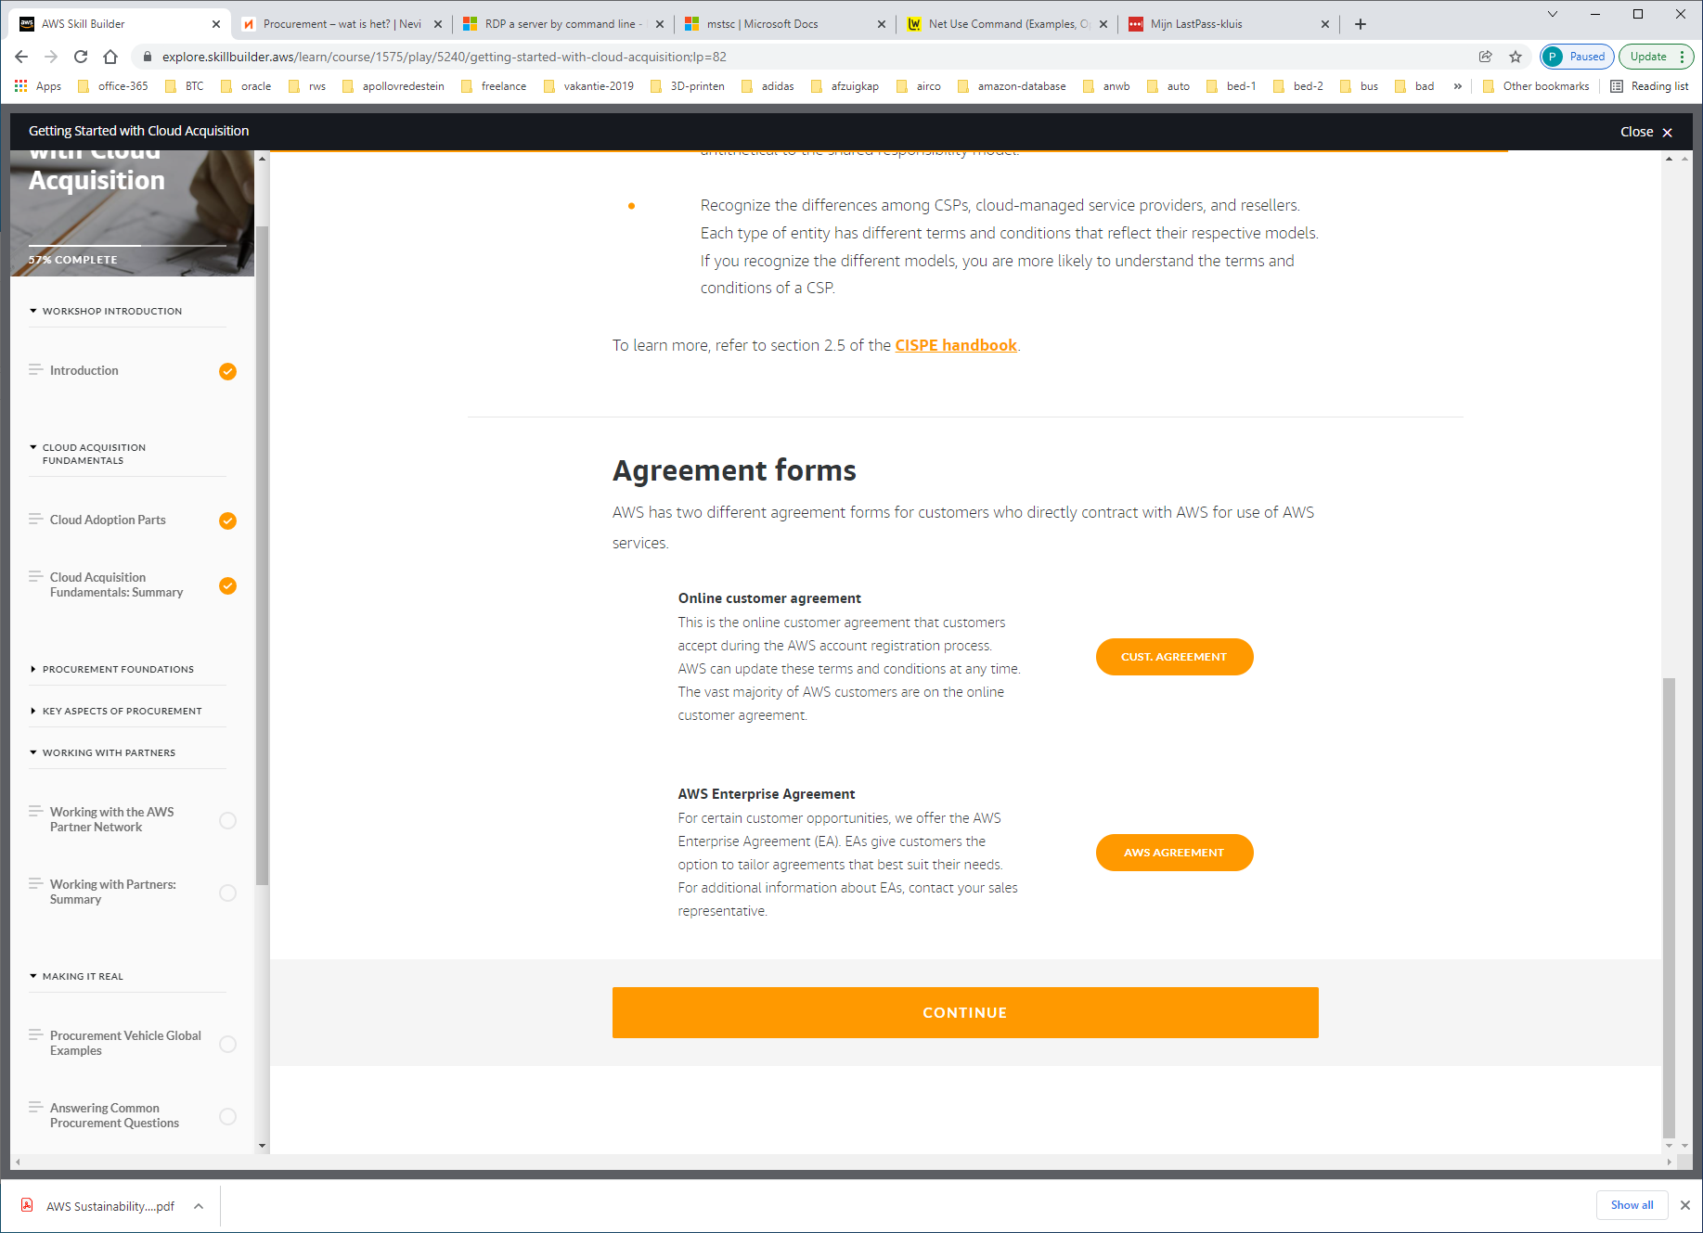

https://aws.amazon.com/agreement/

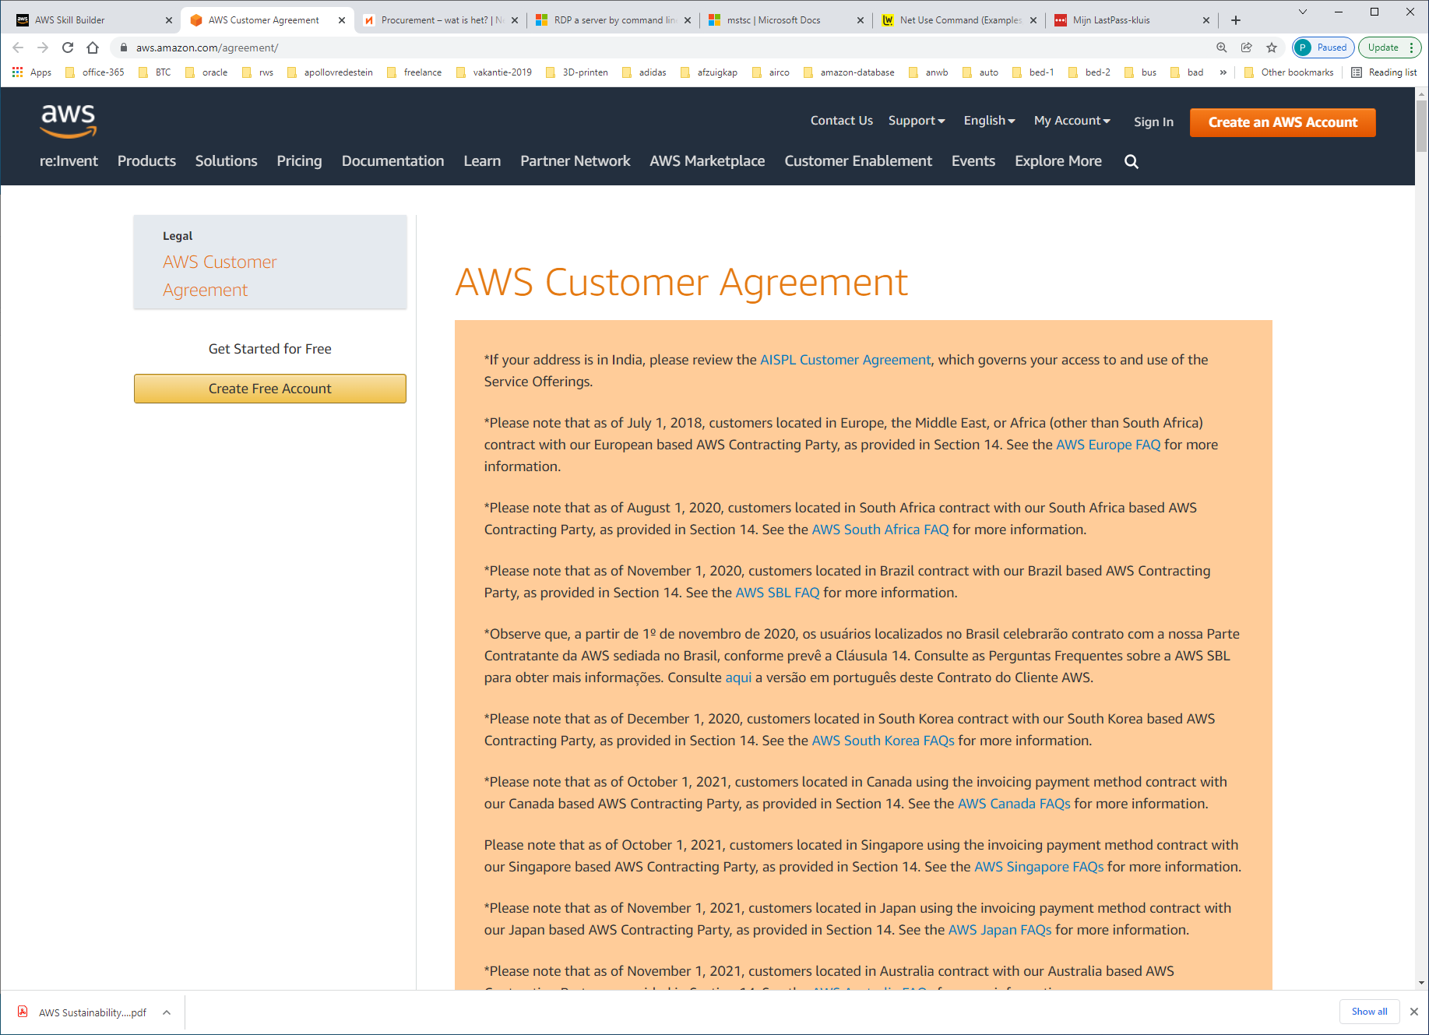

https://aws.amazon.com/pricing/enterprise/

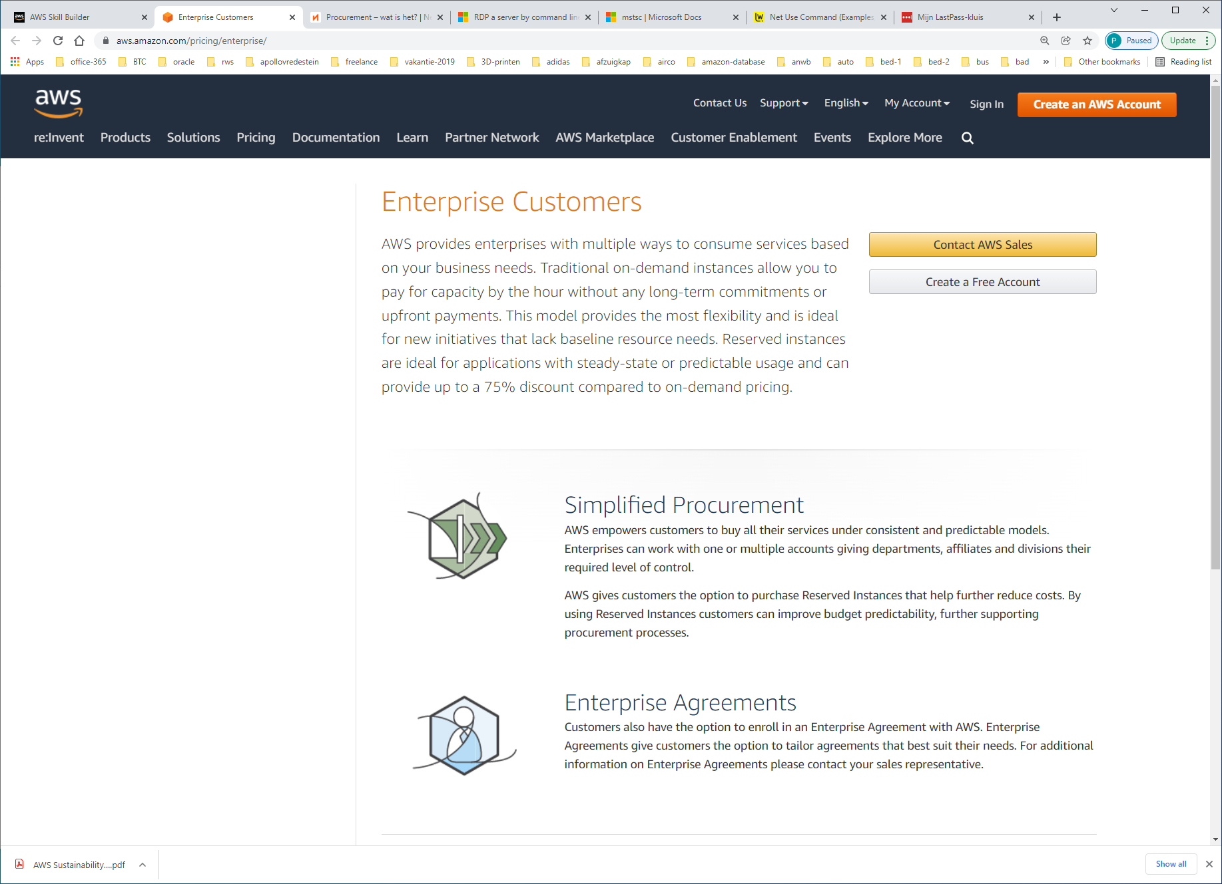

Six key areas affect how cloud is bought: pricing, security, data residency, sustainability, governance, and terms and conditions. If you don’t fully understand these areas, it can prevent you from getting the full benefits of the cloud.

Here are some takeaways when it comes to the key aspects of procurement:

* Cloud pricing is variable. It increases and decreases over time based on vendor pricing—it is not specific to customers.
* You should assess the security and resiliency of the AWS physical infrastructure by using third-party attestations rather than requiring that you audit and assess these elements. Using these existing resources prevents overly burdensome processes and duplication.
* It is important to understand data sovereignty and data residency early on to ensure that you can maximize the benefits of the AWS Cloud offering.
* Any analysis on the climate impact of a data center should consider resource usage and energy efficiency, in addition to power mix. Large-scale CSPs use a power mix that is 28 percent less carbon intense than the global average.
* You need to consider cloud governance in order to successfully operationalize your environment, which should be considered well in advance of a procurement. Because you maintain control over your data, as part of any acquisition strategy, you should assess the CSP’s capabilities to meet your cloud governance needs.
* Cloud terms and conditions are designed to reflect how a cloud services model functions (physical assets are not being purchased). CSPs operate at a massive one-to-many scale to offer standardized services and cannot customize services for individual customer requirements. It is therefore critical that you engage CSPs early to incorporate and use their terms to the fullest extent possible.

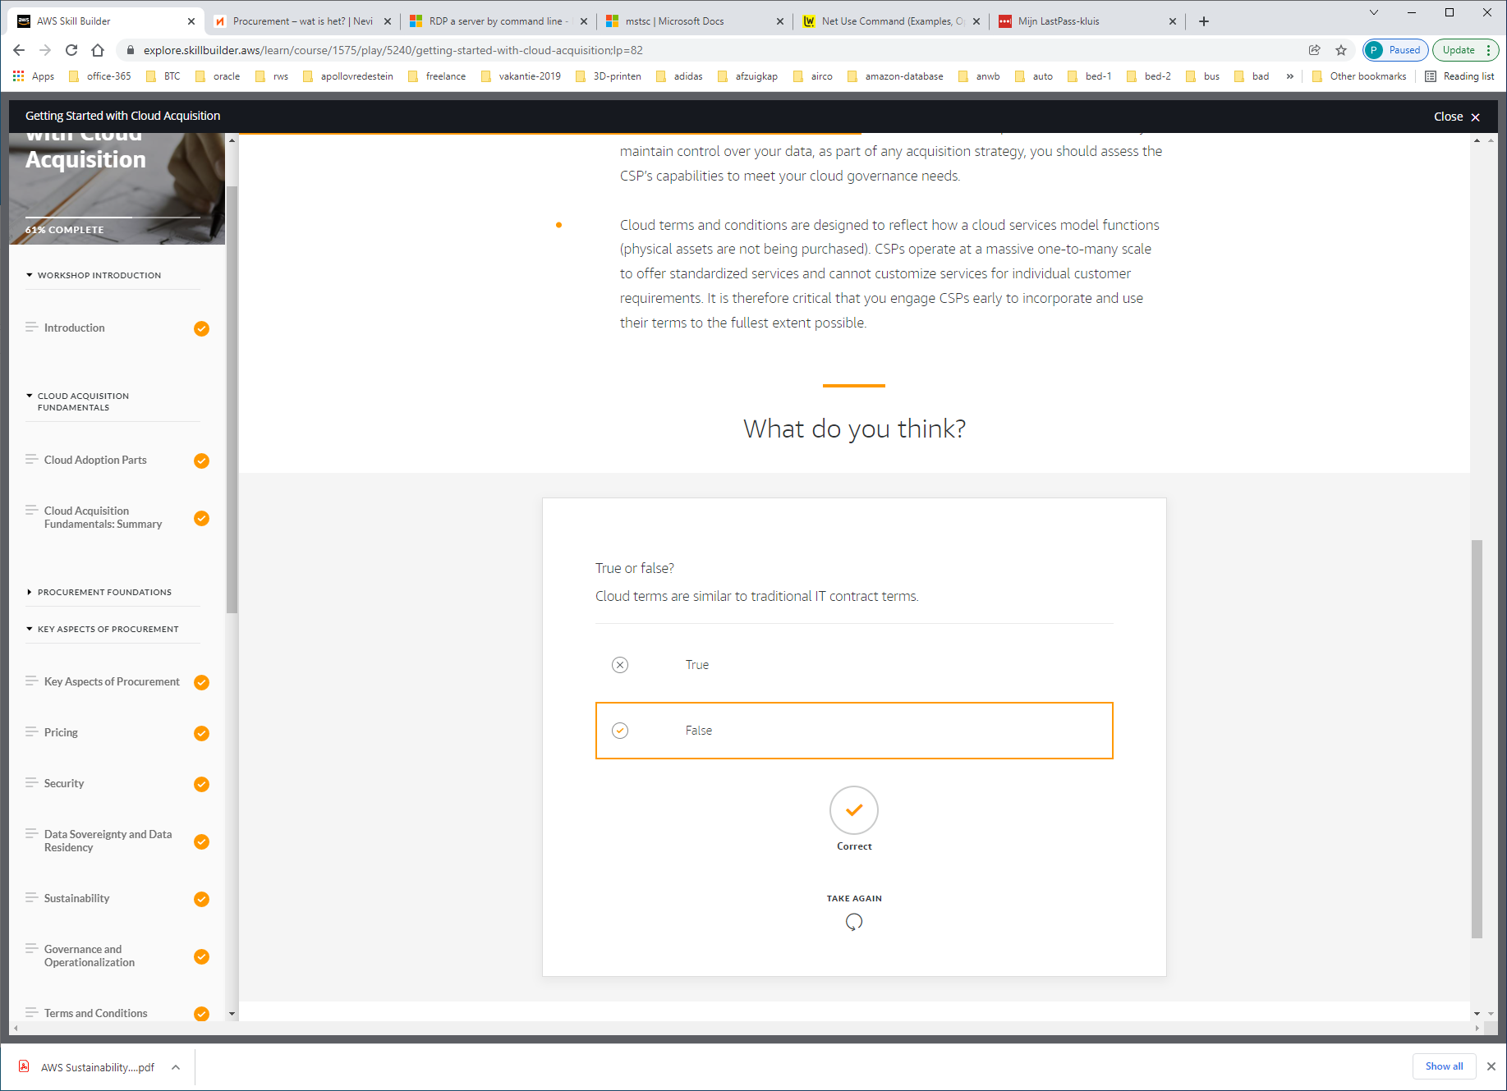

NETWORKING WITH THE AWS PARTNER NETWORK

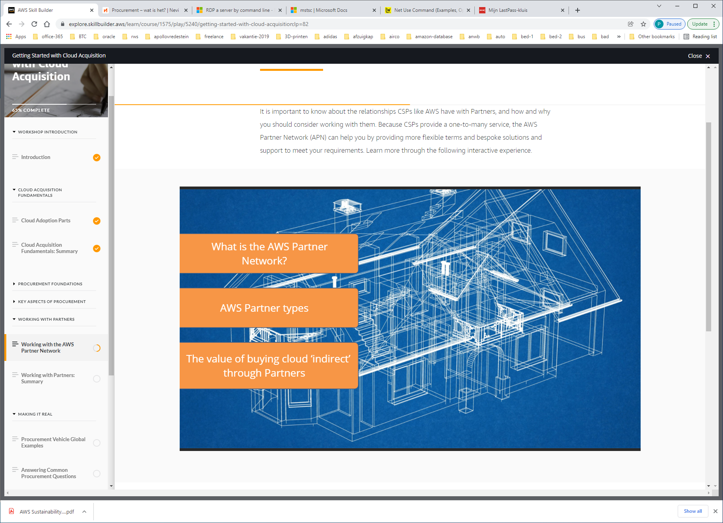

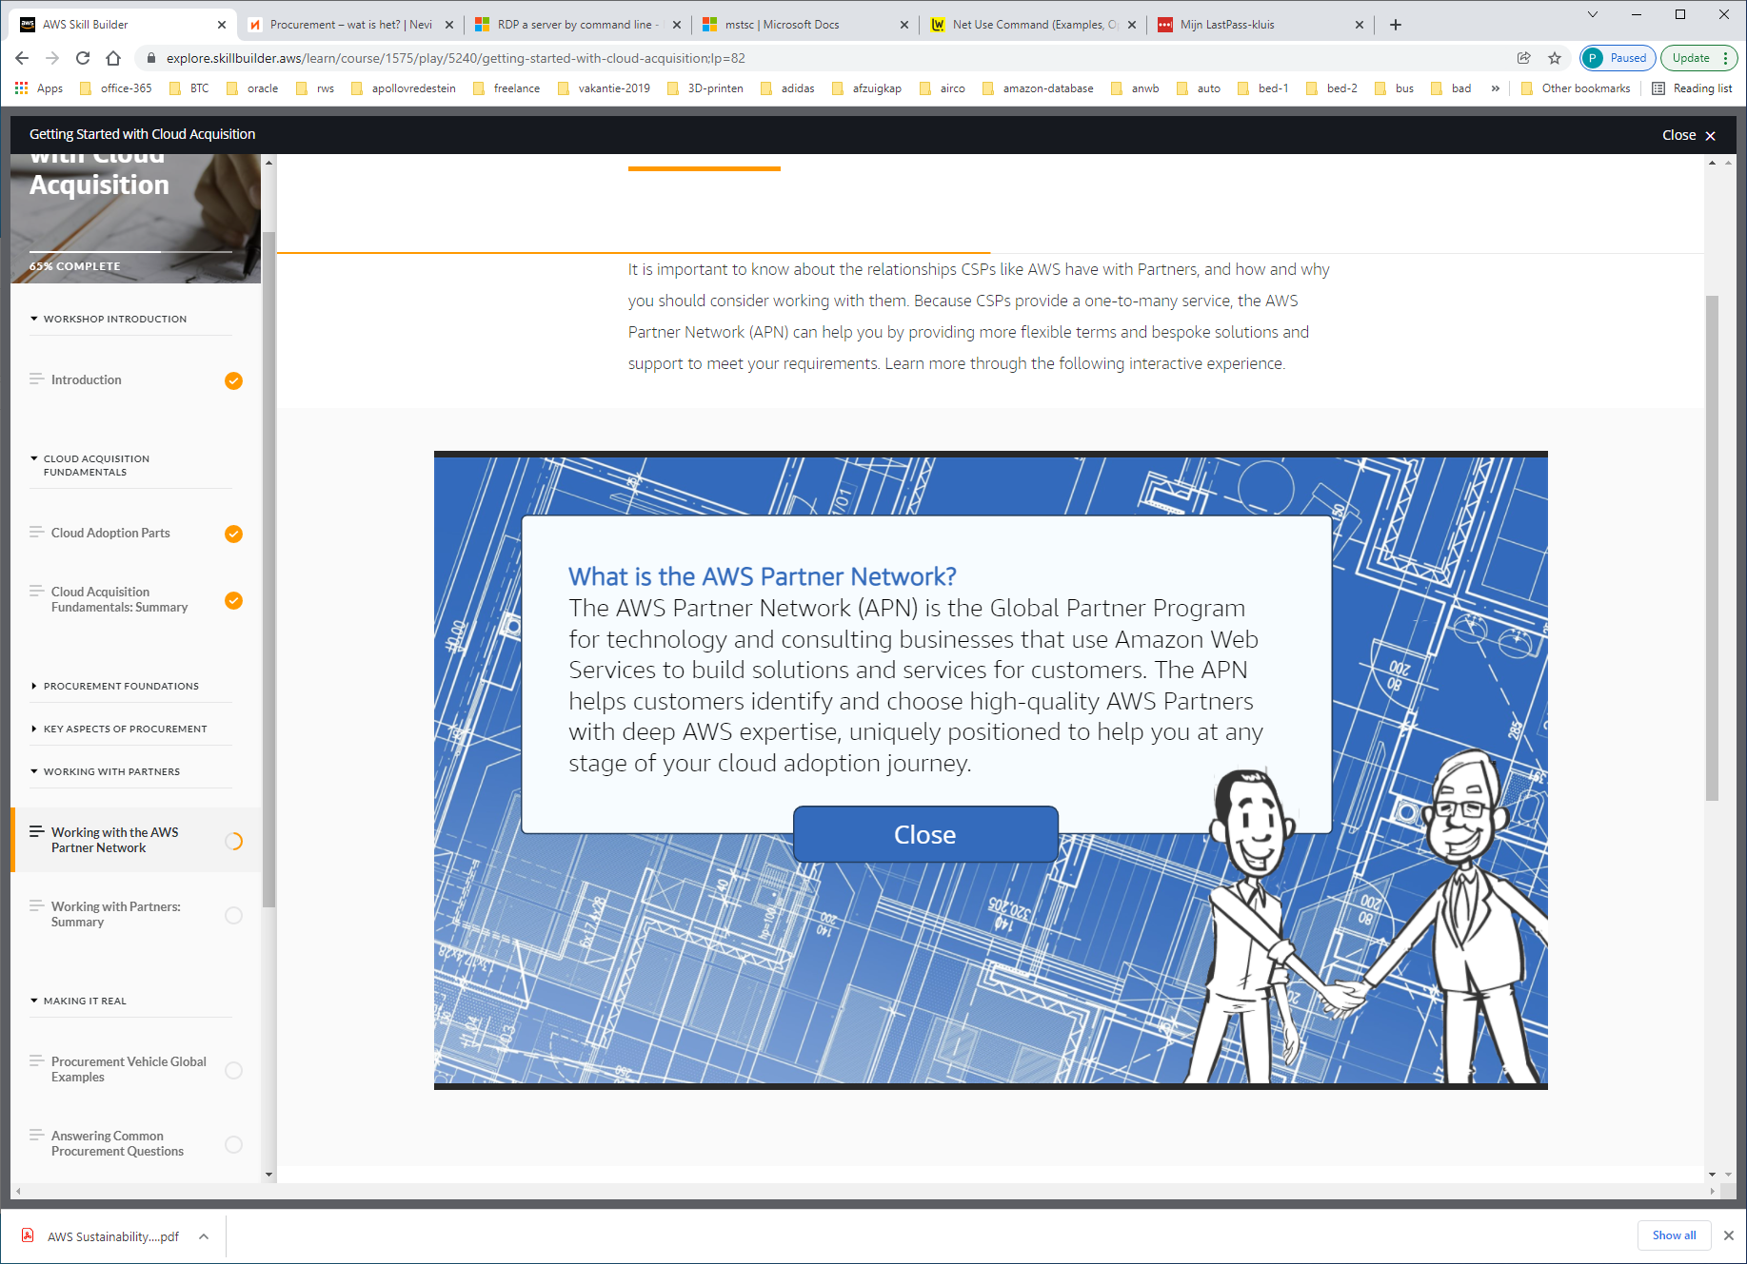

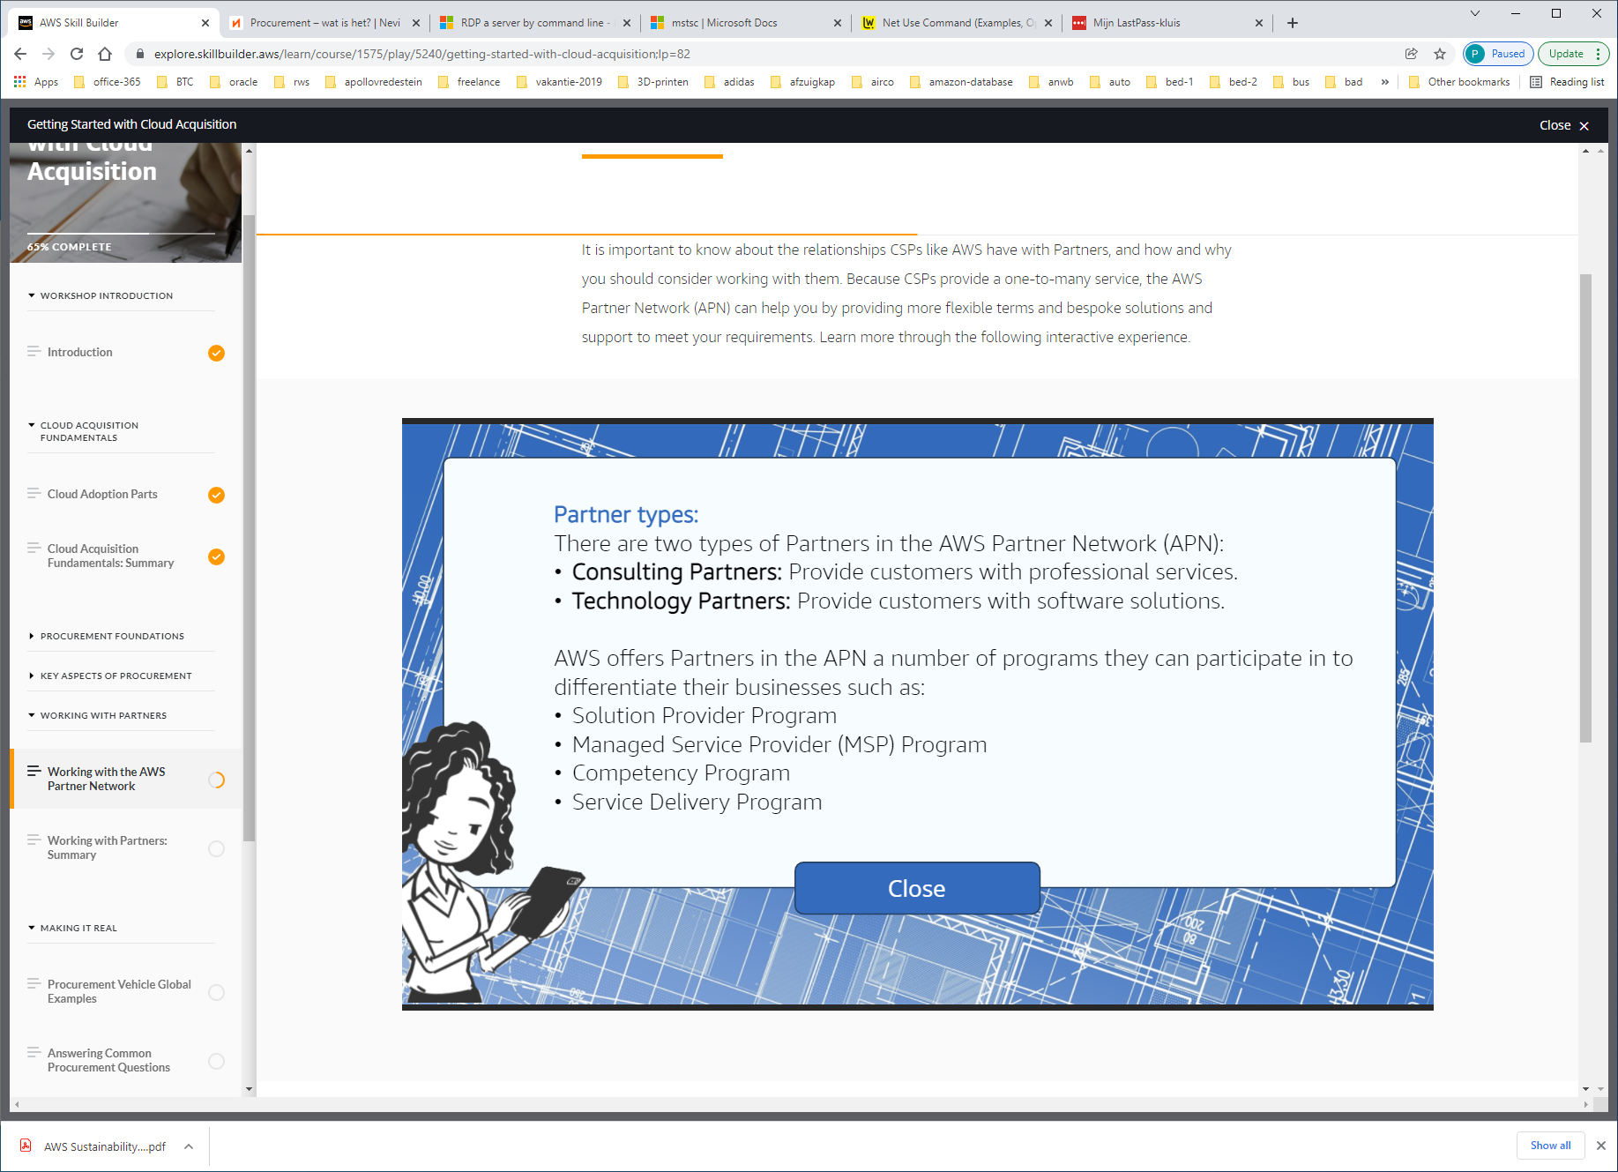

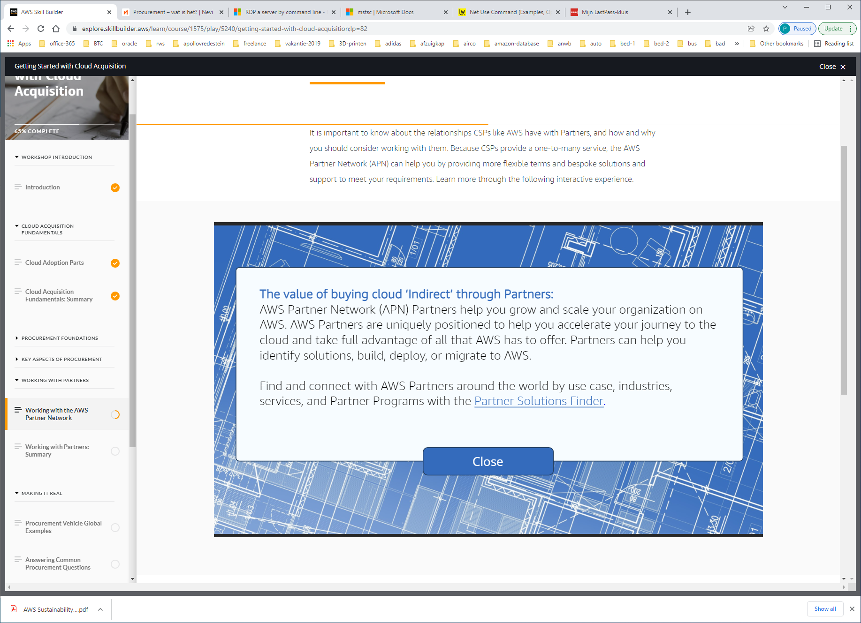

**Using the AWS Partner Network**

Go to the [APN webpage](https://aws.amazon.com/partners/) to see how AWS Partners can help you build successful solutions based on AWS. If you believe you have an opportunity for the APN, you should engage your AWS sales representative as early as possible. They will help you identify Partners for your opportunity so you can assess:

* Different APN capabilities
* Which tier of the APN is the best fit
* What required AWS competencies you need
* Their past performance

It is important to keep your AWS sales representative engaged throughout the sales cycle to ensure that they can support you and the Partner in the process.

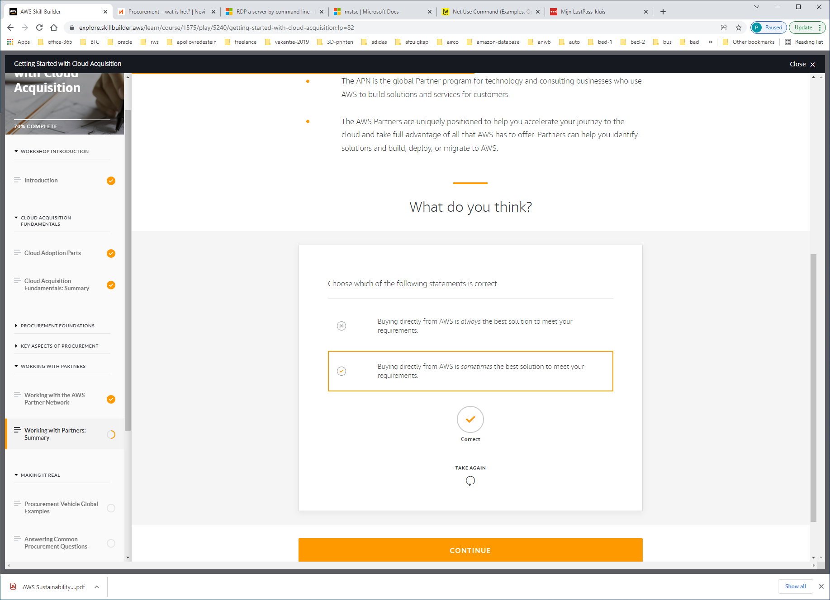

PROCUREMENT VEHICLE GLOBAL EXAMPLES

<https://aws.amazon.com/contract-center/>

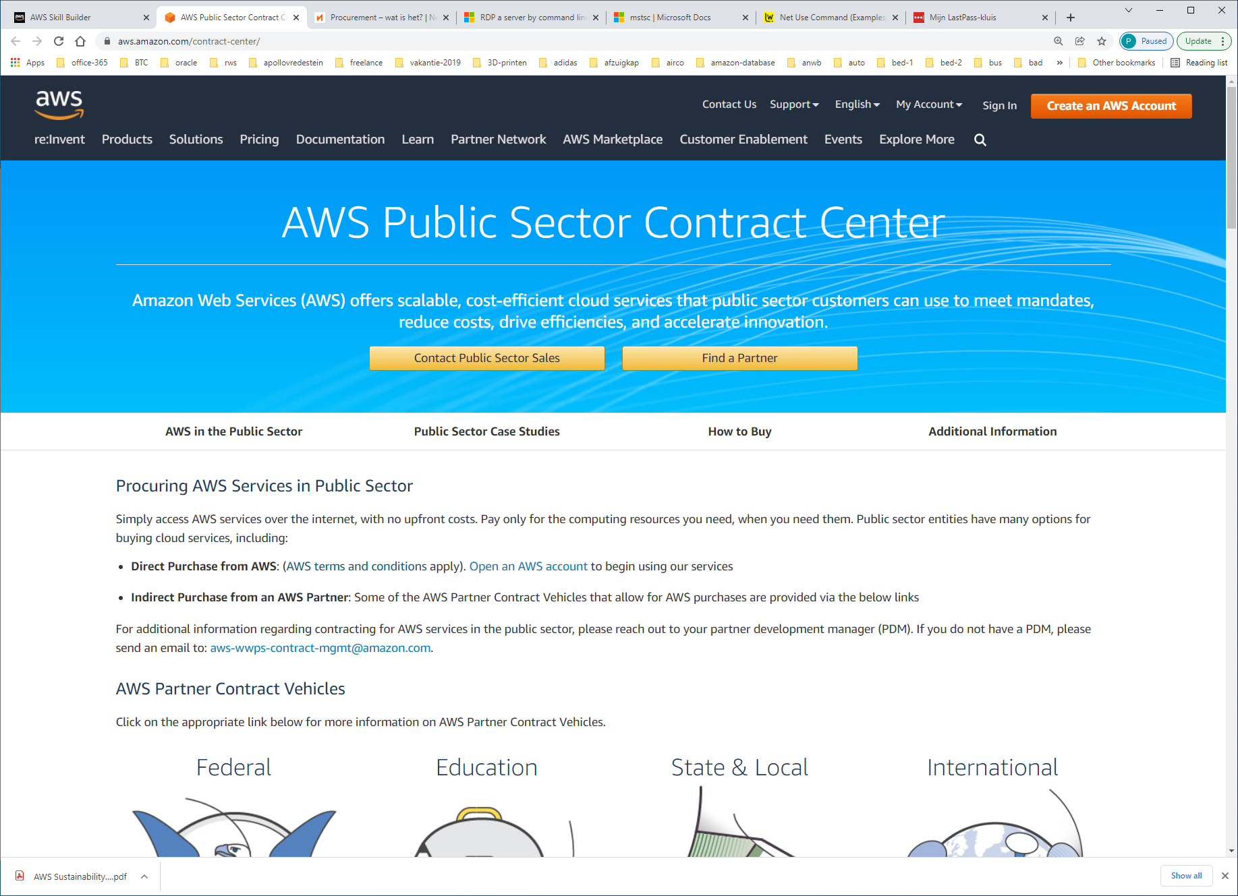

TALKING ABOUT MIGRATIONS

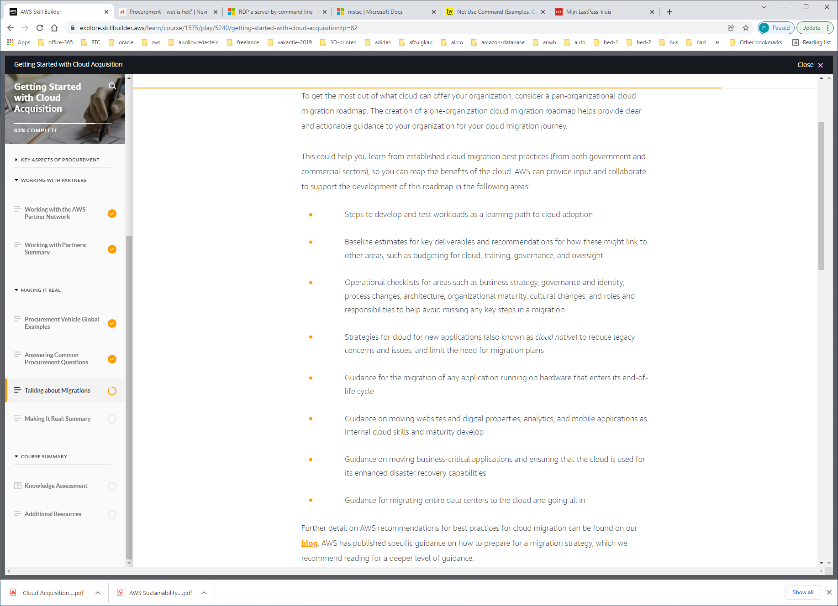

Further detail on AWS recommendations for best practices for cloud migration can be found on our [**blog**](https://aws.amazon.com/blogs/enterprise-strategy/21-best-practices-for-your-cloud-migration/). AWS has published specific guidance on how to prepare for a migration strategy, which we recommend reading for a deeper level of guidance.

More information can also be found in the [**AWS Migration Whitepaper**](https://d1.awsstatic.com/whitepapers/Migration/aws-migration-whitepaper.pdf). For further insights into the tools that AWS provides customers for migrating workloads, refer to this [**tools guide**](https://docs.aws.amazon.com/prescriptive-guidance/latest/migration-tools/migration-tools.pdf).

AGILE APPROACH

To accelerate cloud migrations at scale, AWS recommends setting up an agile program. This includes the use of *epics* (work that can be broken down into specific tasks) for defined workstreams in the readiness and planning phase. By using an agile approach with epics, you start small, iterate, measure, manage, and scale. With this approach, you do the following:

* Structure your work in the form of epics and stories to be able to respond to change.
* Produce a well-prioritized backlog.
* Report your progress.
* Build a migration roadmap to tie business stakeholder needs to technology initiatives.

This program builds the core components of the cloud operational foundation to help align, enable, and mobilize the workforce and resources for a successful migration.

SPRINTS

We further recommend using sprints for migration planning and implementation. With this approach, you can manage sprints with a primary focus on the following.

* Learn by doing. Align, enable, and mobilize a workforce and resources.
* Start small, create early successes, and build to full migration capacity.
* Capture outputs, best practices, and lessons learned to use as building blocks for migrations at scale.
* Create blueprints of agile delivery for scaling migrations based on Wave 1 (the initial wave of migrations with 10 to 30 applications). These blueprints can then be used as a foundation for the readiness and planning migration phase.

After an agile program and sprints have been established, you can scale teams to support your initial wave of migrations to build the migration factory process. This supports a larger move to the cloud. The migration factory process efficiently handles the migration workload because it combines the technical components of a cloud migration with the business and people components. Further information on the agile and sprint processes can be found in the [**AWS Cloud Adoption Readiness Assessment Report**](https://cloudreadiness.amazonaws.com/bfd2391ccfbac30513c6cc8b5c40e3ae.pdf).

AWS-INCENTIVES

AWS provides a range of incentives to customers to support and accelerate their cloud adoption. The AWS Cloud Adoption Framework (AWS CAF) identifies common cloud migration activities and best practices to optimize your migrations and cloud adoption outcomes. The AWS Professional Services (ProServe) team works with customers to create an AWS CAF action plan. The AWS CAF action plan helps you to:

* Prepare for the transition to cloud-based IT.
* Uncover gaps in your existing skills and processes.
* Guide management as you transition to the cloud.

The AWS Cloud Adoption Readiness Tool (CART) helps customers develop efficient and effective plans for cloud adoption and enterprise cloud migrations. This 16-question online survey and assessment report details cloud migration readiness across six perspectives, including business, people, process, platform, operations, and security.  
  
After you complete a CART survey, you can download a customized cloud migration assessment. This includes a heatmap and radar chart with detailed scoring information and resources to help you improve your readiness score. This takeaway report will help you plan and communicate with stakeholders. See the sample [**AWS Cloud Adoption Readiness Assessment Report**](https://cloudreadiness.amazonaws.com/bfd2391ccfbac30513c6cc8b5c40e3ae.pdf)for more information.

AWS MIGRATION PARTNERS

AWS Migration Competency Partners help you accelerate your cloud migrations. They can help you through every stage of migration, accelerating results by providing personnel, tools, and education in the form of professional services. These Partners are, or have a relationship with, an AWS audited Managed Service Provider to help you with ongoing support of AWS workloads.

In order for our AWS Partner Network to achieve the AWS Migration Partner designation, we have assessed their:

* Skills and expertise to help enterprise customers migrate applications and legacy infrastructure to AWS
* Completion of multiple large-scale migrations to AWS

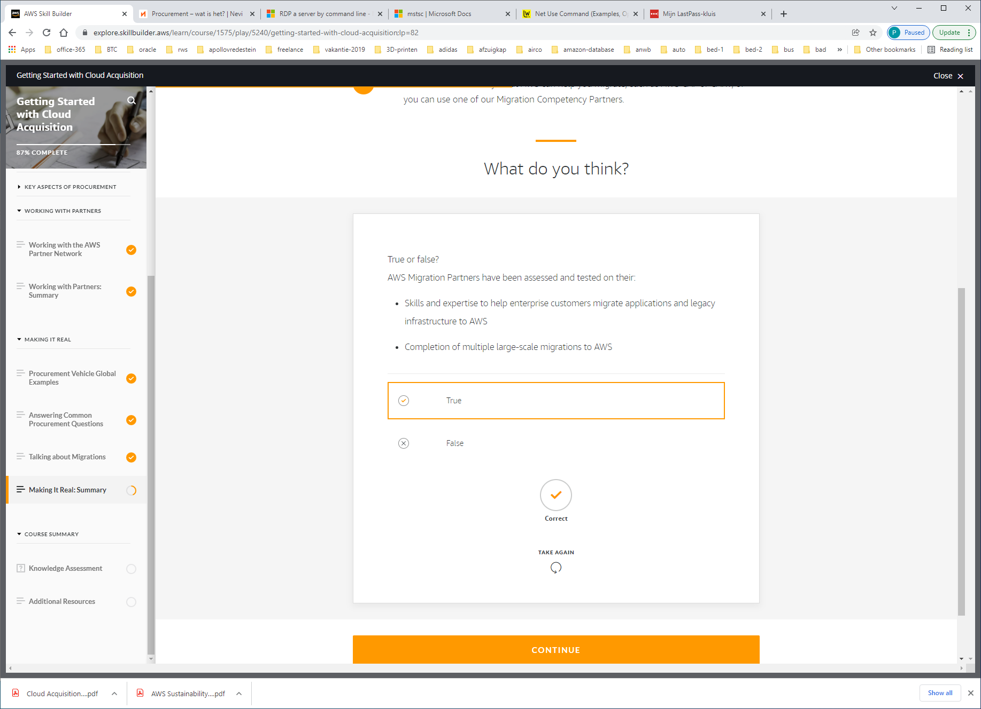



Quiz

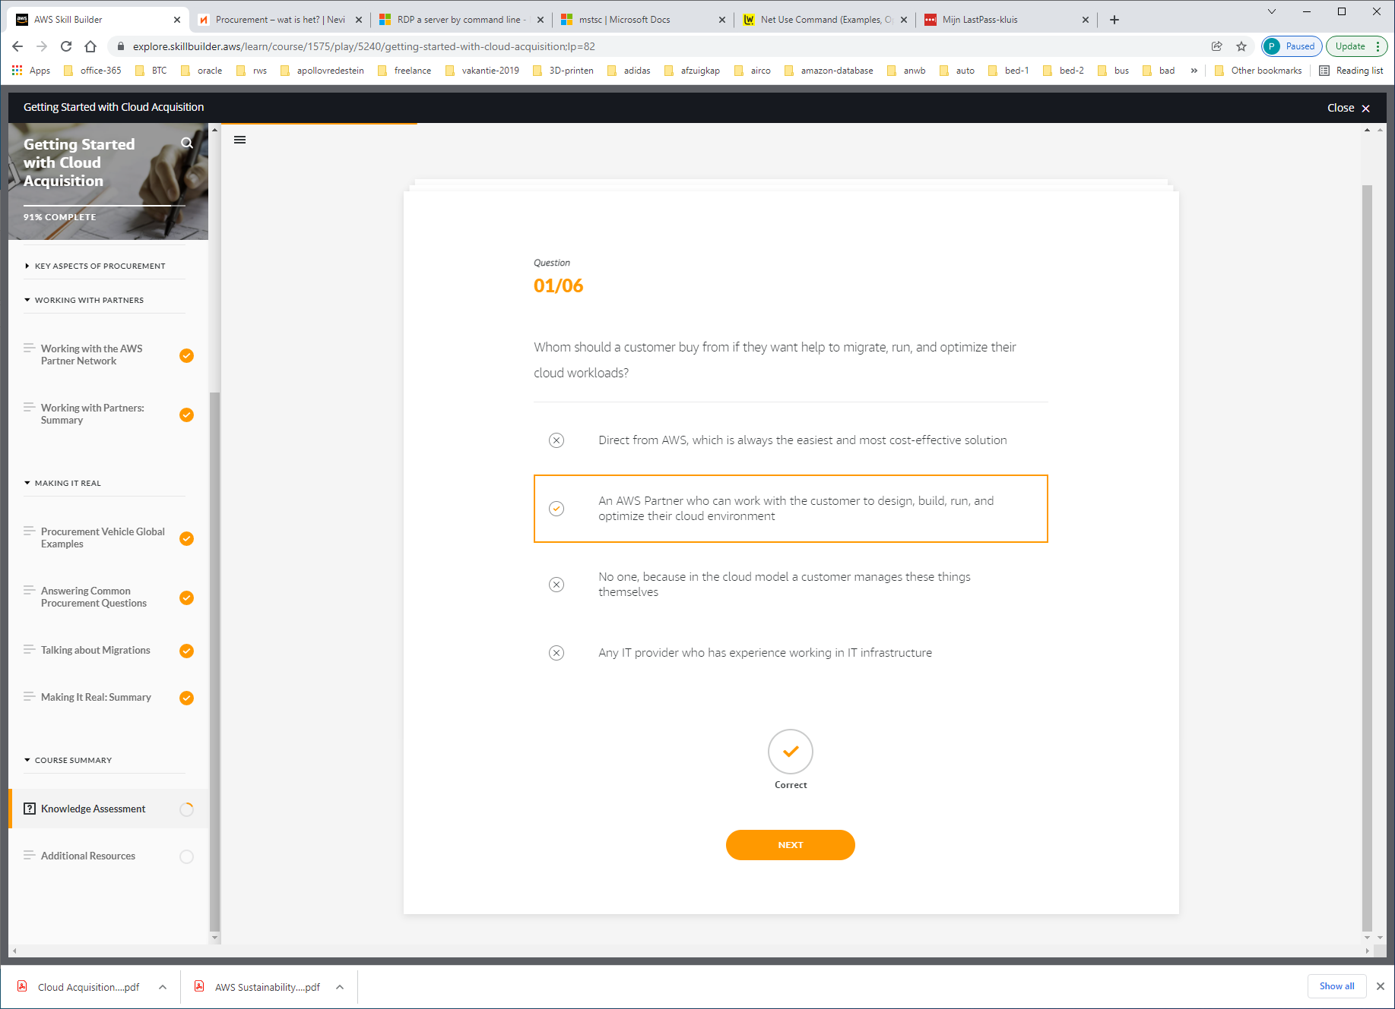

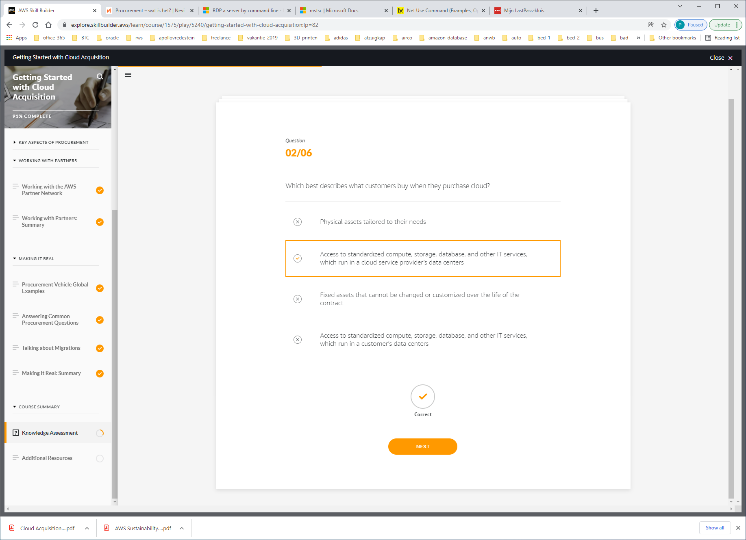

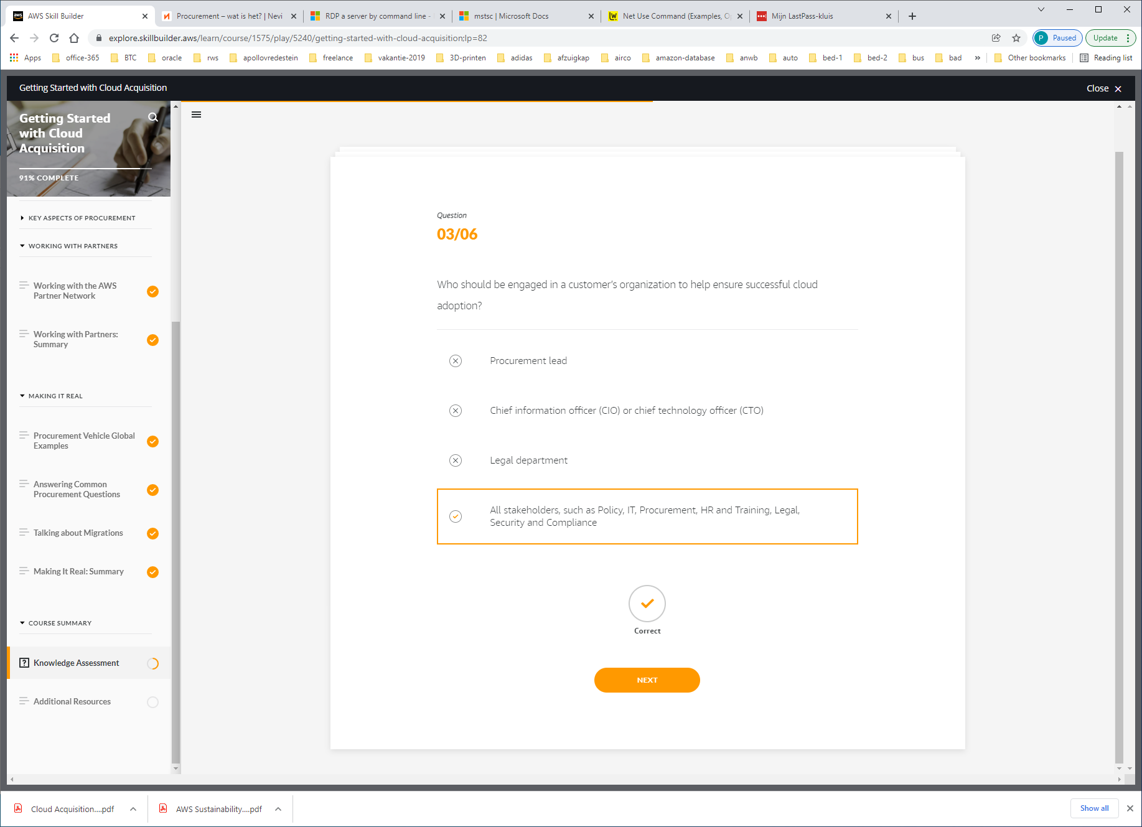

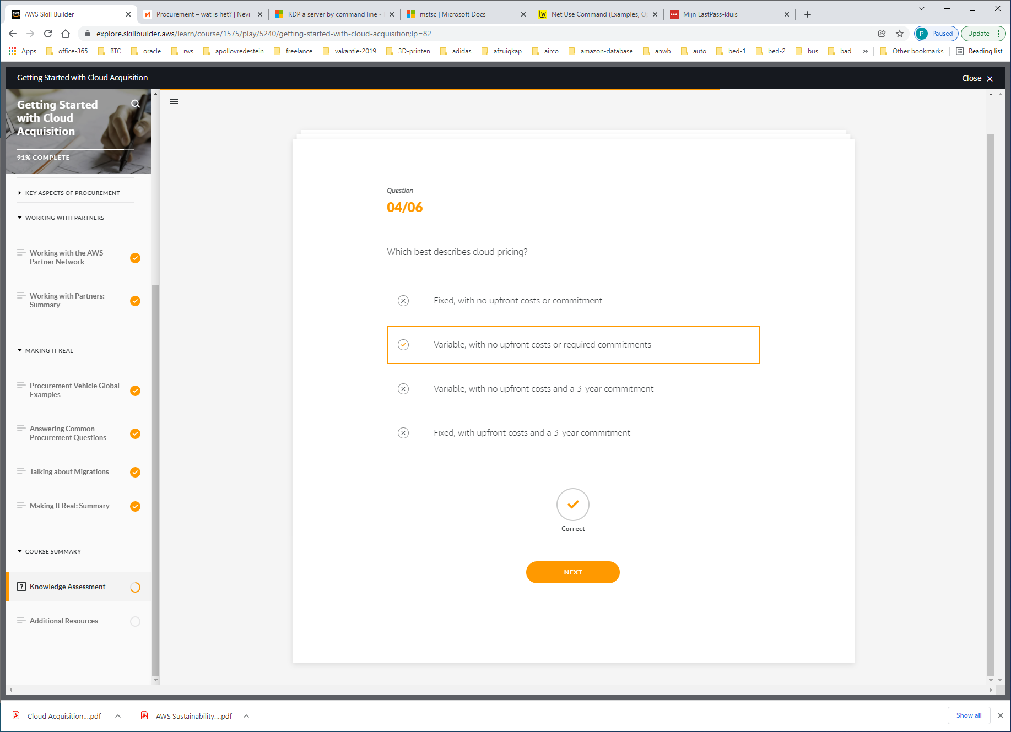

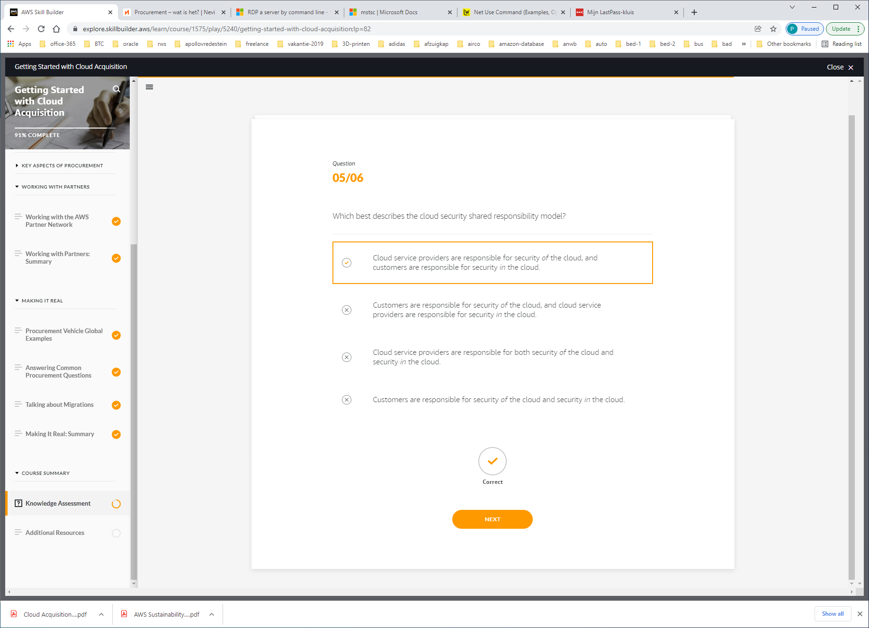

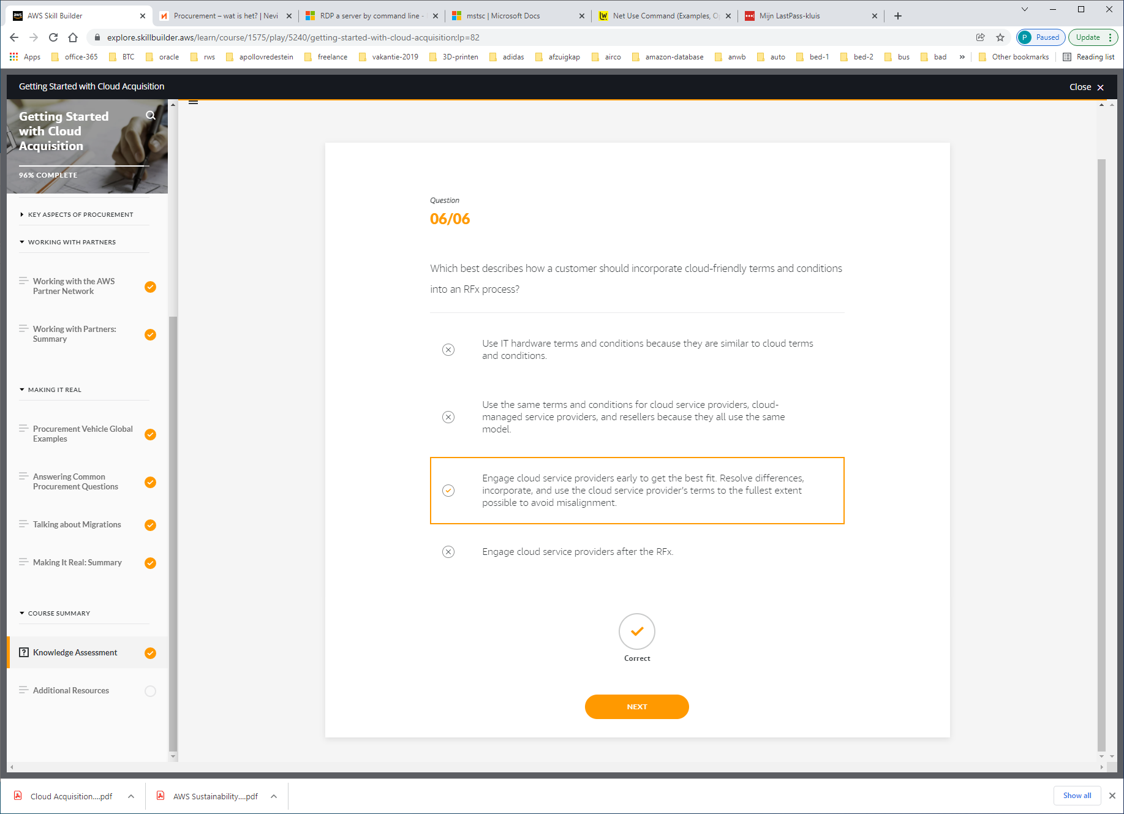

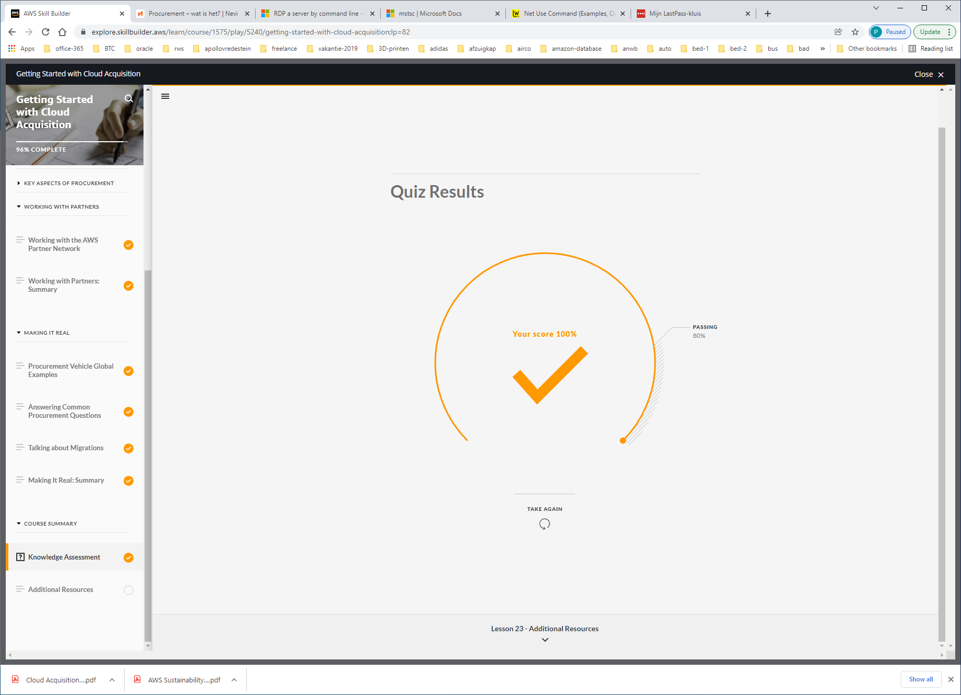

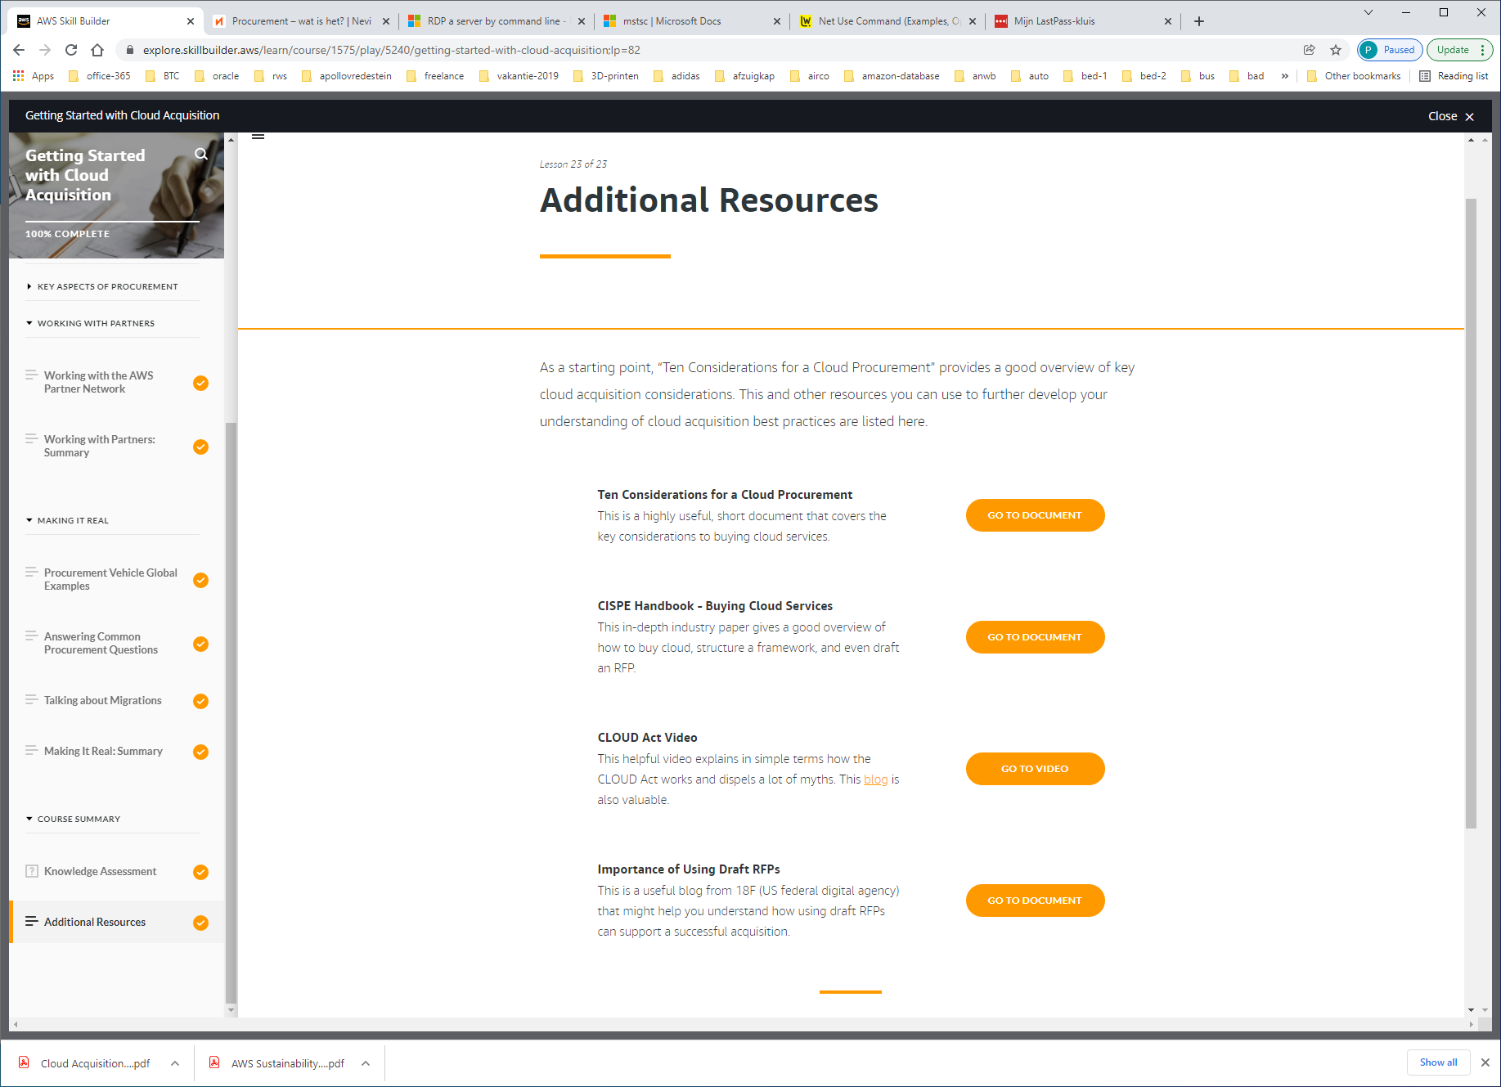

https://aws.amazon.com/blogs/publicsector/ten-considerations-for-a-cloud-procurement/

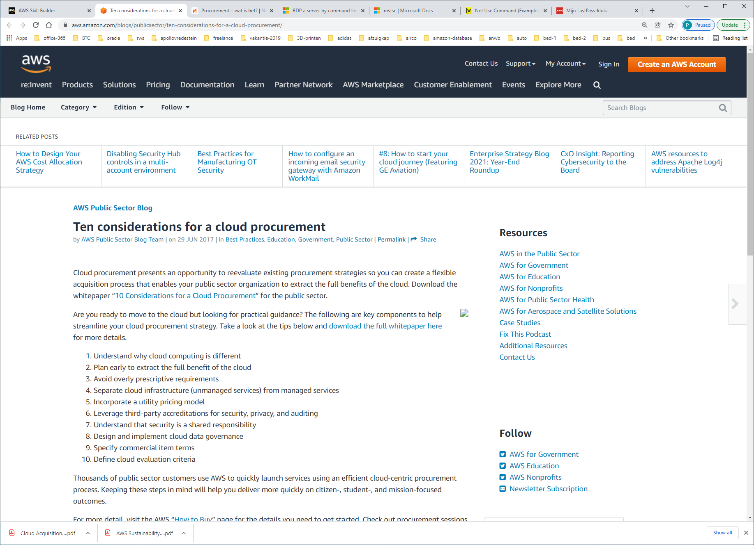

Are you ready to move to the cloud but looking for practical guidance? The following are key components to help streamline your cloud procurement strategy. Take a look at the tips below and [download the full whitepaper here](https://d0.awsstatic.com/whitepapers/10-considerations-for-a-cloud-procurement.pdf) for more details.

1. Understand why cloud computing is different
2. Plan early to extract the full benefit of the cloud
3. Avoid overly prescriptive requirements
4. Separate cloud infrastructure (unmanaged services) from managed services
5. Incorporate a utility pricing model
6. Leverage third-party accreditations for security, privacy, and auditing
7. Understand that security is a shared responsibility
8. Design and implement cloud data governance
9. Specify commercial item terms
10. Define cloud evaluation criteria

<https://cispe.cloud/buying-cloud-services-in-public-sector-handbook/>

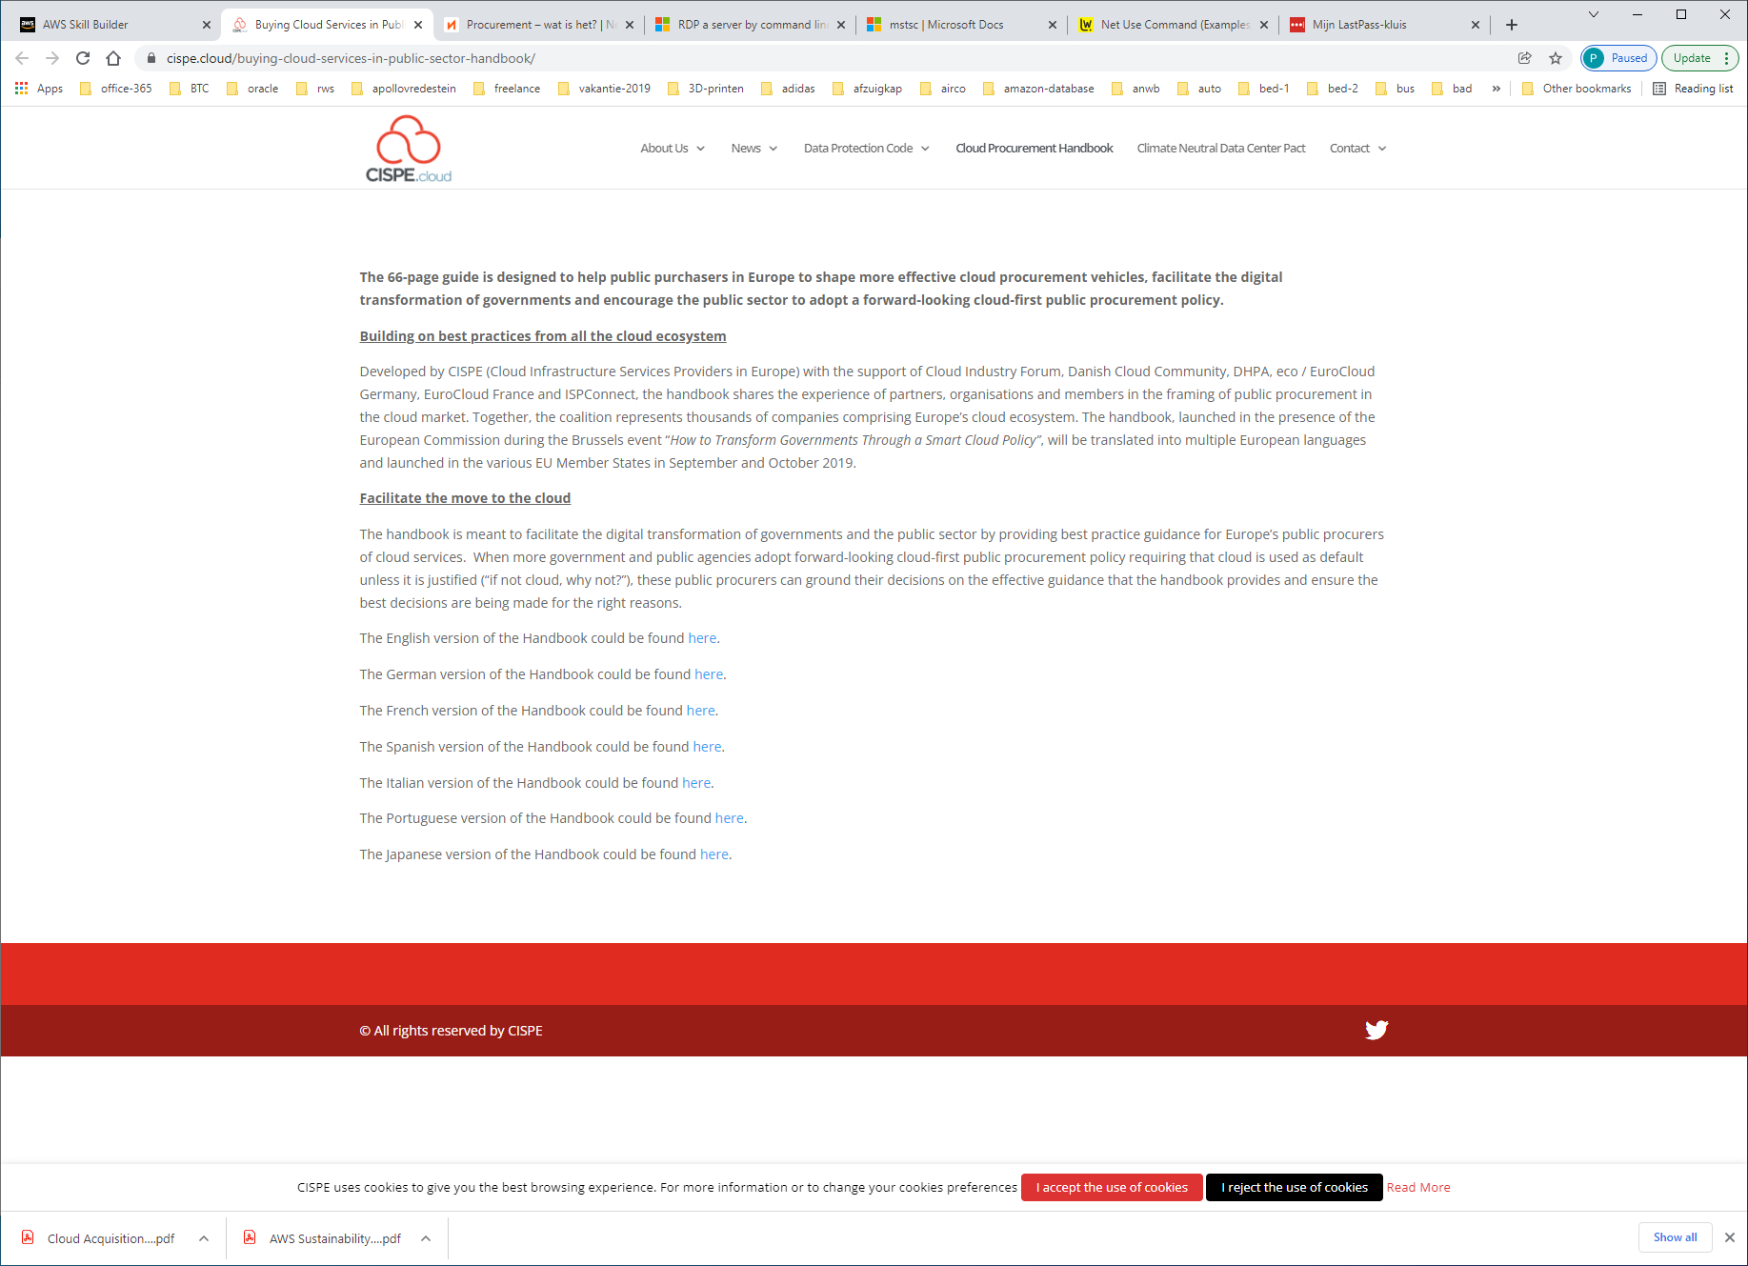

<https://www.youtube.com/watch?v=ptKuaU5qqVA&feature=youtu.be>

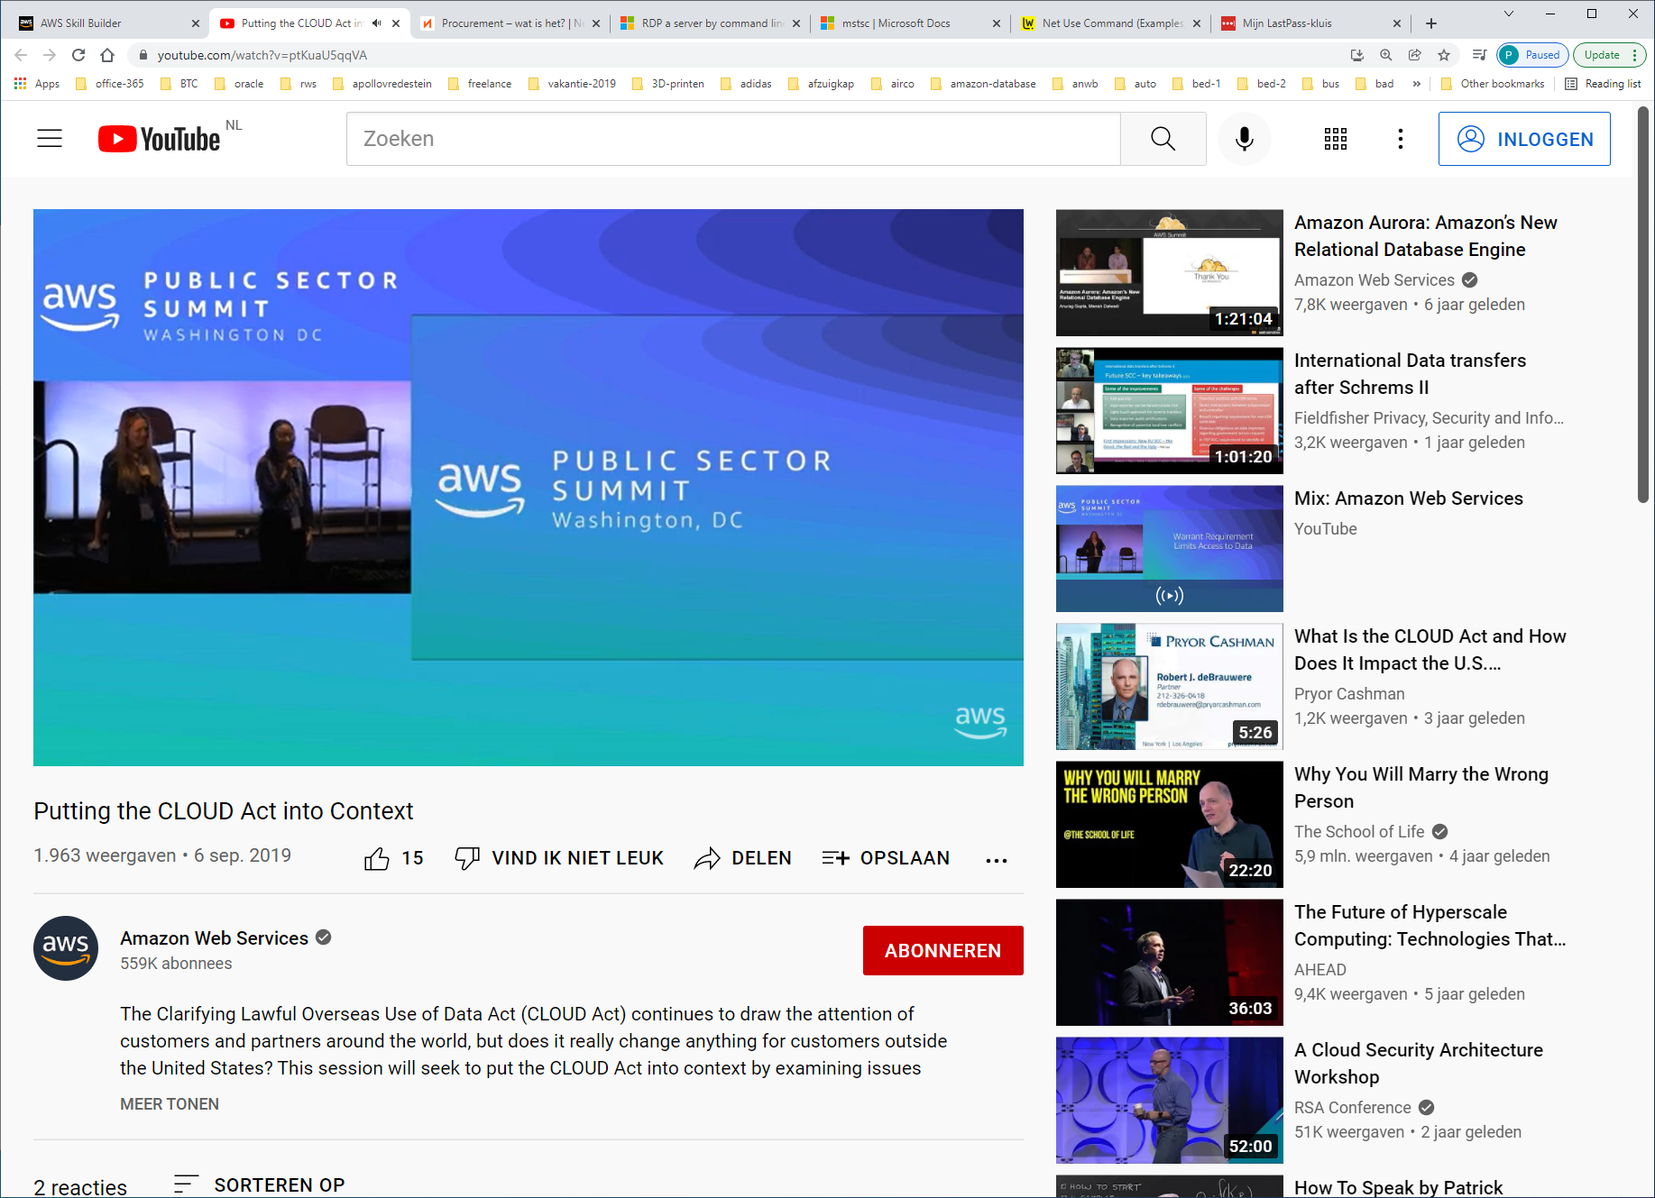

https://18f.gsa.gov/2018/05/22/using-agile-methods-to-improve-the-rfp-process/

